ELECTRONICS SHOP INVENTORY MANAGEMENT SYSTEM
A PROJECT SUBMITTED TO

BHAKTA KAVI NARSINH MEHTA UNIVERSITY
FOR THE DEGREE
OF
BACHLOR OF COMPUTER APPLICATION
IN COMPUTER SCIENCE
Student Name
JETHWA MANSI AMITKUMAR
(ENROLLMENT NUMBER: 20222011080)
Project Guide
Prof. Jaydip Rathod
Associate Professor
Department of Computer Science
Shri V. J. Modha College of Information & Technology- Porbandar

Table of Contents
1 Project Profile 1
1.1 Introduction 1
1.2 Objective 1
1.3 Scope 2
2 Requirement Analysis 4
2.1 Target Audience 4
2.2 Hardware and Software 4
3 Website Planning and Structure 6
3.1 Sitemap 6
3.2 Key Pages 6
3.3 Timeline and Milestones 8
4 Data Dictionary 10
4.1 Tables 10
5 Diagrams 12
5.1 DFD Diagram 12
5.1.1 Context Level (Level-0) 12
5.1.2 Level-1 Diagram 13
5.2 ER Diagram 15
5.3 Use Case Diagram 16
6 User Interface 18
6.1 Admin Panel 18
6.1.1 Login Page 18
6.1.2 Dashboard 21
6.1.3 Manage Employees Page 26
6.1.4 Manage Supplier Page 32
6.1.5 Manage Categories Page 36
6.1.6 Manage Products Page 39
6.1.7 Manage Sales 45
6.2 Employee Side 49
6.2.1 Login Page 49
6.2.2 Employee Dashboard 51
7 Budget and Financial Plan 63
7.1 Cost Estimation 63
7.2 Financial Planning 64
8 Future Enhancement 65
9 Conclusion 66
10 References 67

Project Profile

Introduction

The Electronics Shop Inventory Management System is a desktop-based application developed using Python's Tkinter library for the graphical user interface (GUI) and MySQL for the backend database. This system is designed to help electronics shops efficiently manage their inventory, ensuring accurate stock tracking and streamlined operations.
The primary objective of this project is to automate and simplify inventory-related tasks, such as managing product categories, tracking supplier information, monitoring stock levels, and maintaining employee details. By replacing traditional manual methods with this digital solution, the system minimizes errors, enhances productivity, and provides real-time access to critical data.
With an intuitive user interface and robust database integration, the Electronics Shop Inventory Management System ensures smooth functionality, making it a reliable tool for shop owners to manage their day-to-day business activities effectively.

Objective

The main objective of the Electronics Shop Inventory Management System is to provide an efficient and user-friendly solution for managing inventory operations in electronics shops. This system is designed to address the challenges of traditional manual inventory management by offering a streamlined and automated approach. The key objectives include:
Efficient Inventory Tracking
To accurately monitor the stock levels of electronics products, ensuring timely restocking and minimizing overstocking or stockouts.
Category Management
To organize products into categories for easy retrieval and better classification of inventory items.
Supplier Management
To maintain a comprehensive database of suppliers, including their details and supplied products, enabling seamless coordination and procurement.
Employee Management
To manage employee details, roles, and responsibilities, ensuring accountability and proper record-keeping.
Data Accuracy and Integrity
To minimize errors in inventory records by leveraging a centralized database, ensuring the integrity of critical data.
Tax Calculation and Management
To automate the calculation of applicable taxes, ensuring compliance and simplifying financial operations.
User-Friendly Interface
To provide an intuitive GUI for shop owners and employees, enabling easy navigation and efficient operation.
Scalability and Customization
To allow flexibility for adding more features or scaling the system as the shop grows.

Scope

The Electronics Shop Inventory Management System is a comprehensive solution designed to automate and streamline the management of inventory and related business operations in electronics shops. The system is tailored for small to medium-sized businesses and includes the following features:
1. Core Functionalities
Employee Management:
Add, update, and manage employee records, including roles and responsibilities.
Maintain employee activity logs to ensure accountability.
Supplier Management:
Maintain detailed supplier records, including contact information and products supplied.
Facilitate seamless coordination with suppliers for procurement.
Category Management:
Organize inventory into categories for efficient browsing and management.
Simplify the retrieval of products within specific categories.
Product Management:
Add, update, and delete product details, including pricing, stock levels, and descriptions.
Track product movement to monitor stock availability.
Billing System:
Generate detailed bills with tax calculations.
Maintain billing records for reporting and audit purposes.

2. Database Management
Centralized Data Storage:
Store all data securely using a MySQL database.
Enable quick retrieval and modification of records.
3. Tax and Financial Management
Automated calculation of applicable taxes.
Integration of tax details into billing for accurate financial reporting.
4. User Interface
GUI Integration:
A user-friendly interface built with Python Tkinter for easy navigation.
Simplified workflows for employees with minimal technical knowledge.
5. Reporting and Analysis
Generate reports for employee records, supplier activities, category details, stock levels, and billing data.
Use analytics to make informed decisions regarding inventory and business operations.

Requirement Analysis

Target Audience

The Electronics Shop Inventory Management System is designed to cater to the following primary audiences:
Electronics Shop Owners:
Business owners managing small to medium-sized electronics shops.
Individuals seeking a reliable and automated solution to handle inventory, suppliers, employees, and billing operations.
Owners aiming to streamline business processes, reduce manual effort, and improve accuracy in daily operations.
Employees:
Staff members responsible for managing inventory, updating product records, and handling billing.
Employees involved in day-to-day operations who require an easy-to-use system to enhance productivity and ensure smooth workflows.

Hardware and Software

Hardware Requirements
Processor:
Minimum: Dual-core processor
Recommended: Intel i5 or higher
RAM:
Minimum: 4 GB
Recommended: 8 GB or higher
Storage:
Minimum: 250 GB HDD
Recommended: 512 GB SSD or higher

Display:
Resolution: 1366 x 768 or higher
Screen Size: 15.6 inches or larger for optimal GUI display
Input Devices:
Keyboard and Mouse
Additional Peripherals:
Printer (for generating bills and reports, optional)
Software Requirements
Operating System:
Windows 10 or higher
Linux (Ubuntu 18.04 or higher)
Programming Environment:
Python 3.7 or higher
Tkinter library for GUI
Database Management System:
MySQL 8.0 or higher
Additional Tools and Libraries:
MySQL Connector for Python
Required Python libraries (e.g., pandas, openpyxl for reporting if applicable)
Development Environment:
Integrated Development Environment (IDE) like PyCharm, Visual Studio Code, or any preferred Python IDE
Other Software:
XAMPP or WAMP (optional, for database management during development)
Drivers and Utilities:
Printer drivers (if using a printer)
Database backup utilities for MySQL

Website Planning and Structure

Sitemap
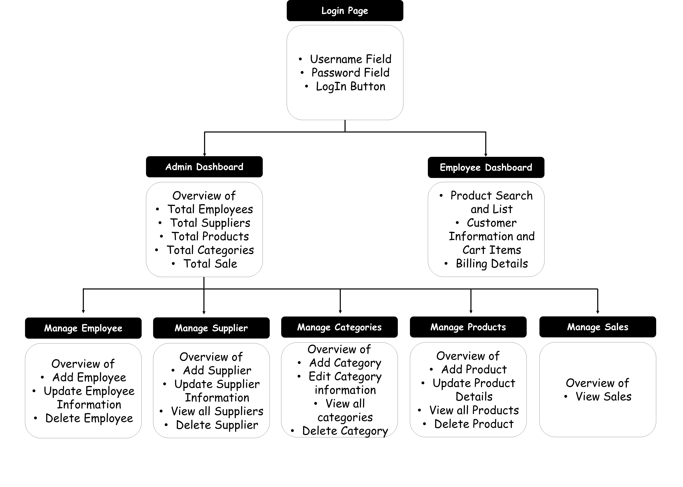

Key Pages

Dashboard
- Purpose:
- Serves as the central hub of the system, providing a summary of key metrics and quick navigation to other pages.
- Features:
- Displays overall statistics like total employees, suppliers, products, categories, and sales.
- Includes shortcuts to critical functionalities such as employee, supplier, product, and category management.

Employee Management Page
- Purpose:
  - Allows the shop owner to manage employee details efficiently.
- Features:
  - Add, update, and delete employee records.
  - View employee details, including name, role, and contact information.
  - Manage employee roles and permissions.
Products Management Page
- Purpose:
  - Enables efficient management of product inventory.
- Features:
  - Add new products with details like name, price, stock quantity, and description.
  - Update or delete product records.
  - Search and filter products by category or stock level.
  - Monitor stock availability to avoid overstocking or stockouts.
Categories Management Page
- Purpose:
  - Facilitates the organization of products into categories for better management.
- Features:
  - Create new categories and assign products to them.
  - Update or delete existing categories.
  - View category-wise product counts for better organization.
Supplier Management Page
- Purpose:
  - Maintains records of suppliers for smooth procurement processes.
- Features:
  - Add, update, or delete supplier records.
  - View supplier details, including name, contact information, and supplied products.
  - Track supplier activity and manage relationships efficiently.
Sales Report Page
- Purpose:
  - Provides detailed insights into sales performance.
- Features:
  - Generate reports for daily, monthly, or custom date ranges.
  - Analyze sales trends and revenue statistics.
  - Export reports to formats like Excel or PDF for further analysis.

Billing Dashboard
- Purpose:
  - Streamlines the billing process for sales transactions.
- Features:
  - Generate invoices with itemized billing and tax details.
  - Apply discounts or promotional offers as needed.
  - Print or save invoices for record-keeping.
  - Maintain a log of all bills for future reference.

Timeline and Milestones

Timeline:
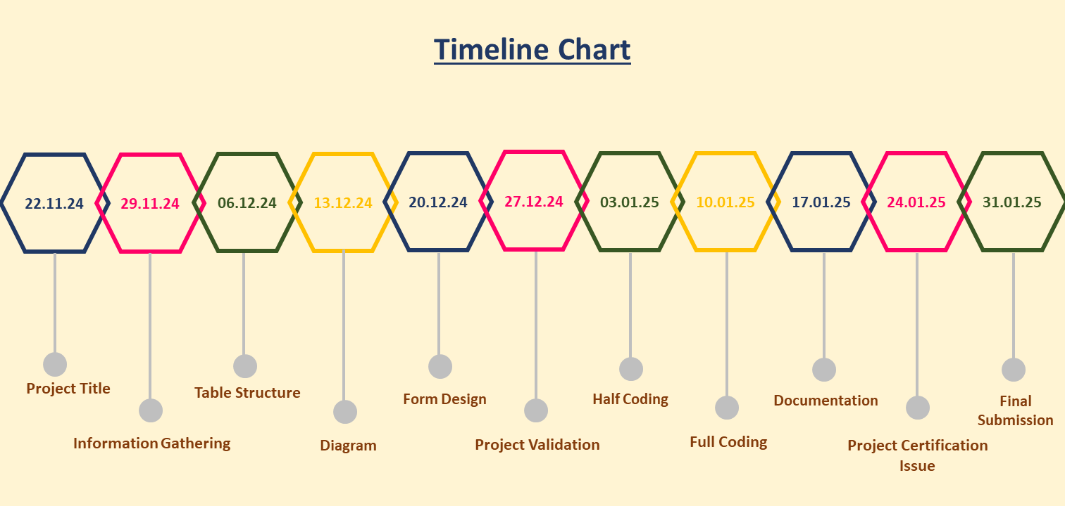

Milestones:
- 22.11.24 - Project Title & Information Gathering
  - Finalize the project title: "Electronics Shop Inventory Management System."
  - Research the requirements and features needed for the system.
- 29.11.24 - Table Structure Design
  - Design the database schema, including tables for employees, suppliers, products, categories, and billing.
- 06.12.24 - Diagram
  - Create system architecture diagrams (ER diagram, flowchart, and use-case diagrams).
- 13.12.24 - Form Design
  - Develop the GUI layouts for all key pages, such as the dashboard, employee management, and billing.
- 20.12.24 - Project Validation
  - Ensure initial validation of forms and database connectivity for proper data handling.
- 27.12.24 - Half Coding Completion
  - Complete 50% of the coding, including database integration and basic functionality for employee and product management.
- 03.01.25 - Full Coding Completion
  - Finalize the coding for all modules, ensuring end-to-end functionality.
- 10.01.25 - Documentation
  - Prepare comprehensive project documentation, including an introduction, objectives, scope, and key page descriptions.
- 17.01.25 - Project Certification Issue
  - Receive certification from relevant authorities or instructors.
- 24.01.25 - Final Submission
  - Submit the completed project, including code, documentation, and reports.

Data Dictionary

Tables

Table Name: categories
Field Name | Data Type | Field Length | Constraints | Description
category_id | INT | 20 | PRIMARY KEY | Product’s Category Id, auto generated
category_name | VARCHAR | 100 | NOT NULL | Product’s Category Name
description | TEXT | 100 | NOT NULL | Product’s Category Description

Table Name: products
Field Name | Data Type | Field Length | Constraints | Description
product_id | INT | 20 | PRIMARY KEY | Product’s Id, auto generated
product_name | VARCHAR | 100 | NOT NULL | Product’s Name
category_id | INT | 20 | FOREIGN KEY | Product’s Category id
price | DECIMAL | 8,2 | NOT NULL | Product’s Price
quantity | INT | 20 | NOT NULL | Product’s Quantity
supplier_id | INT | 20 | FOREIGN KEY | Product’s Supplier id

Table Name: suppliers
Field Name | Data Type | Field Length | Constraints | Description
supplier_id | INT | 20 | PRIMARY KEY | Product’s Supplier Id, auto generated
supplier_name | VARCHAR | 100 | NOT NULL | Product’s Supplier Name
contact | VARCHAR | 10 | NOT NULL | Supplier’s Contact Number
address | TEXT | 100 | NOT NULL | Supplier Address

Table Name: customers
Field Name | Data Type | Field Length | Constraints | Description
customer_id | INT | 20 | PRIMARY KEY | Customer’s Id, auto generated
customer_name | VARCHAR | 100 | NOT NULL | Customer’s Name
customer_contact | VARCHAR | 10 | NOT NULL | Customer’s Contact Number
pur_products | TEXT | 255 | NOT NULL | Purchased Products
price | VARCHAR | 10 | NOT NULL | Price of Purchased Products
discount | VARCHAR | 10 | NOT NULL | Discount on Purchased Products
total_price | VARCHAR | 10 | NOT NULL | Total price

Table Name: employees
Field Name | Data Type | Field Length | Constraints | Description
employee_id | INT | 20 | PRIMARY KEY | Employee’s Id, auto generated
employee_name | VARCHAR | 100 | NOT NULL | Employee’s Name
employee_email | VARCHAR | 100 | NOT NULL | Employee’s Email
employee_gender | VARCHAR | 10 | NOT NULL | Employee’s Gender
employee_dob | VARCHAR | 10 | NOT NULL | Employee’s Date Of Birth
employee_contact | VARCHAR | 10 | NOT NULL | Employee’s Contact Number
employement_type | VARCHAR | 100 | NOT NULL | Employee’s Employement type like Full Time,Part Time, Contract, Intern
employee_education | VARCHAR | 100 | NOT NULL | Employee’s Education
employee_workshift | VARCHAR | 100 | NOT NULL | Employee’s Work Shift like Morning, Evening and Night
employee_address | TEXT | 100 | NOT NULL | Employee’s Address
employee_doj | VARCHAR | 100 | NOT NULL | Employee’s Date Of Joining
employee_salary | VARCHAR | 100 | NOT NULL | Employee’s Salary

Diagrams

DFD Diagram

Context Level (Level-0)

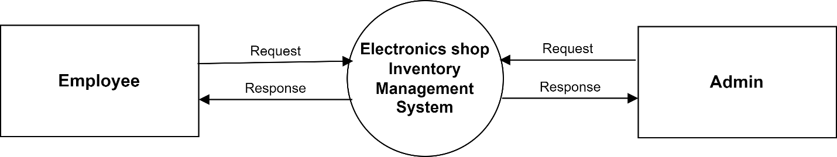

Level-1 Diagram

Admin Side

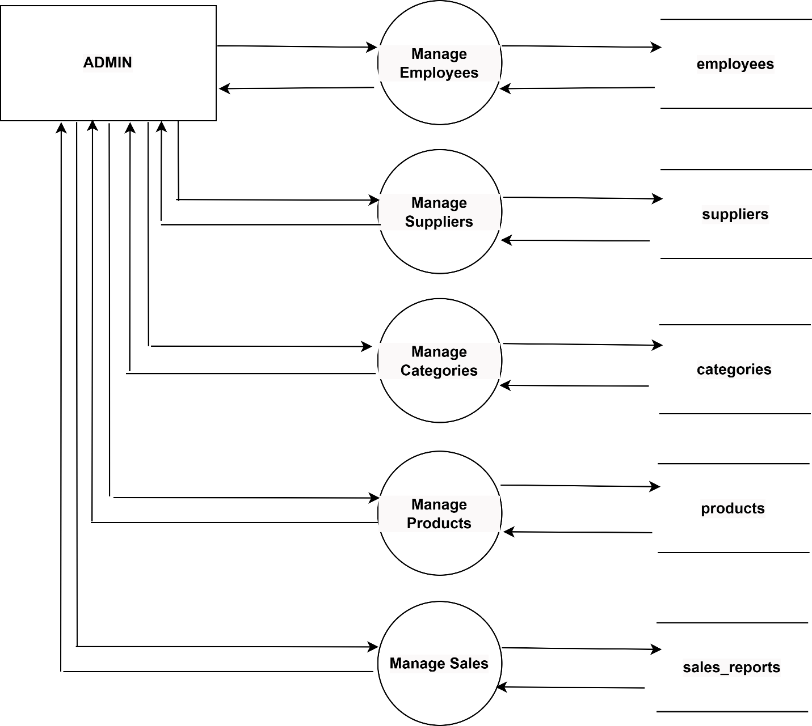

Employee

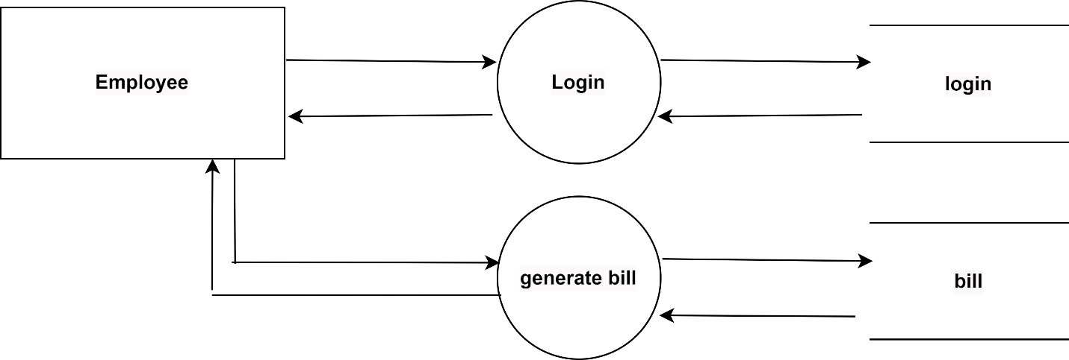

ER Diagram

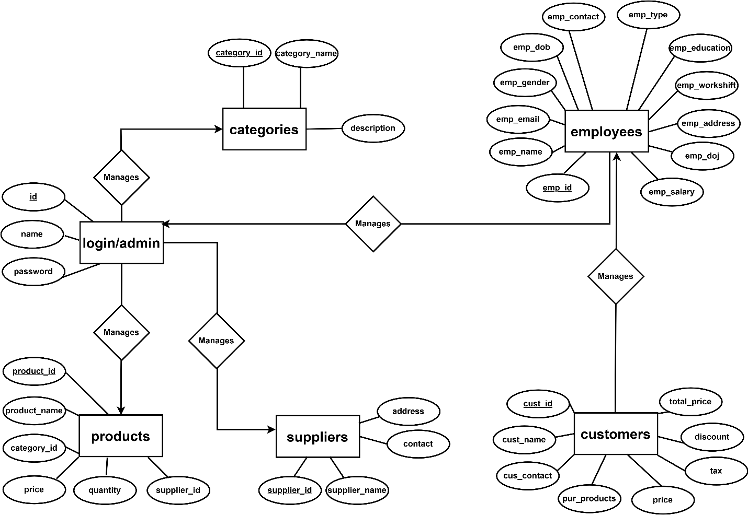

Use Case Diagram

Admin

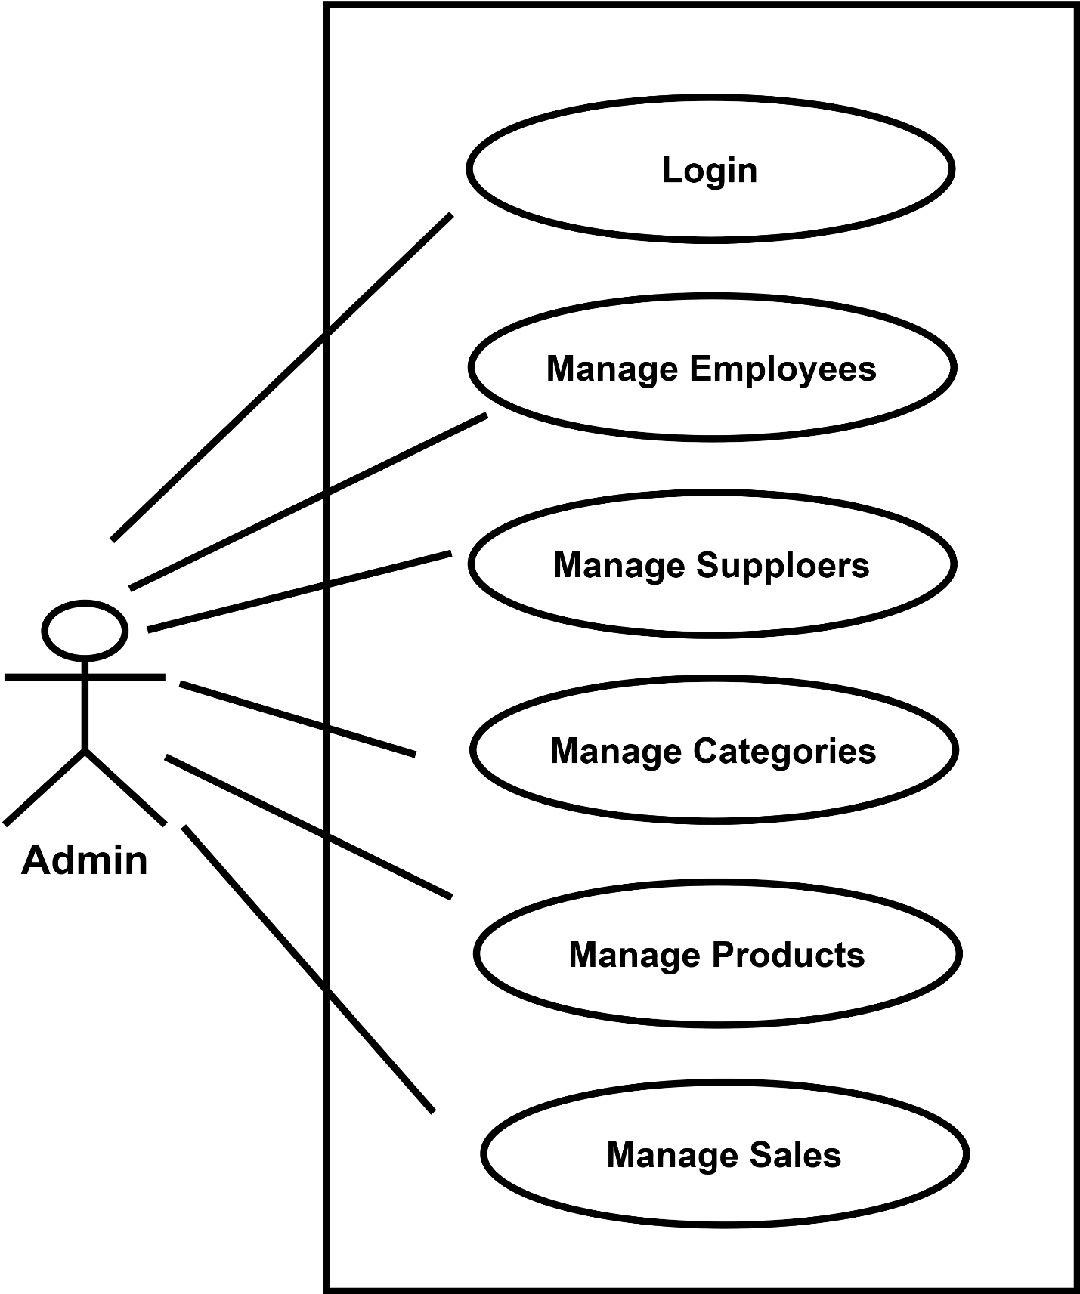

Employee
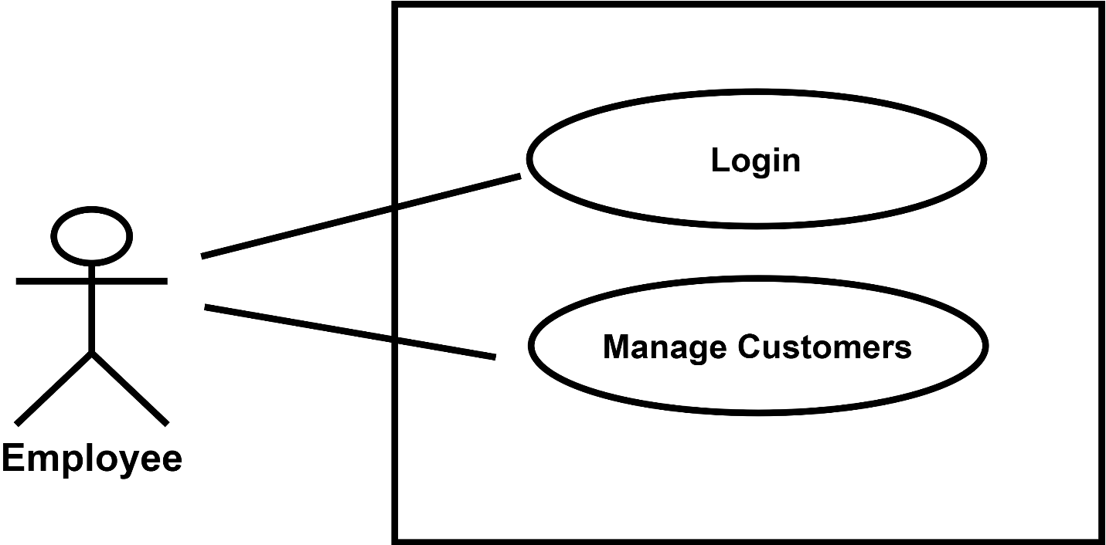

User Interface

Admin Panel

Login Page

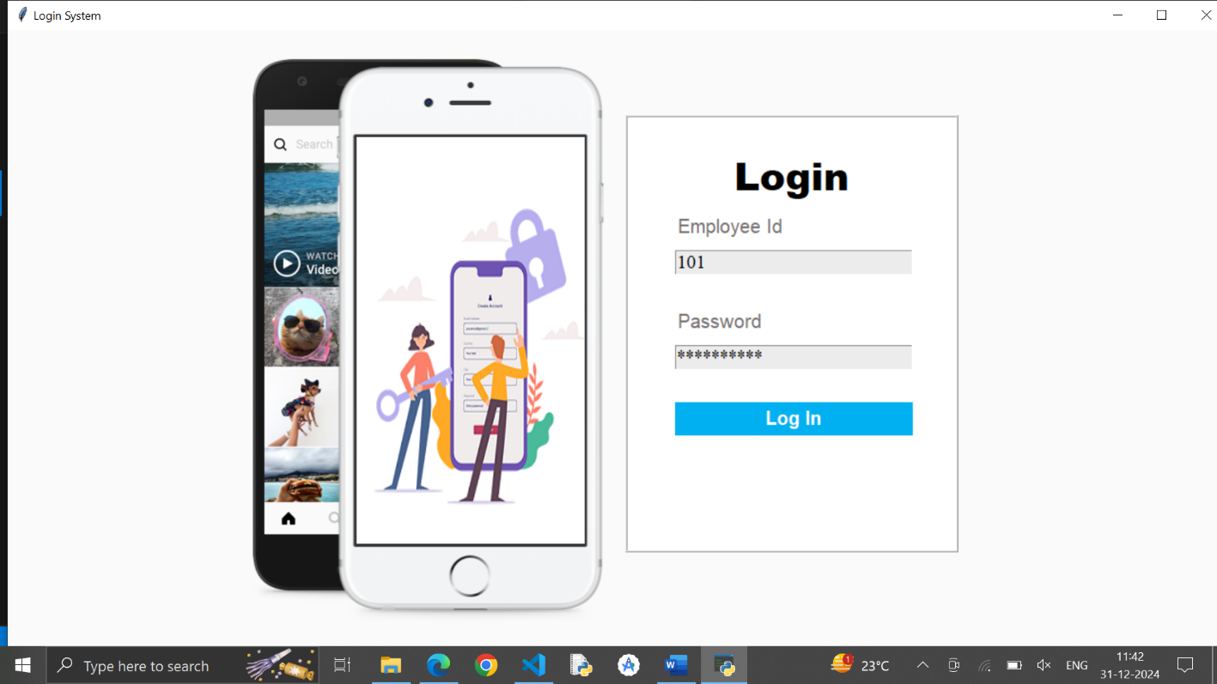
Description: It is login form for admin.

Code:
from tkinter import *
from PIL import ImageTk
from tkinter import messagebox
import mysql.connector
import os
class Login_System:
def __init__(self,root):
self.root=root
self.root.title("Login System")
self.root.geometry("1350x700+0+0")
self.root.config(bg="#fafafa")

self.phone_image=ImageTk.PhotoImage(file="phone.png")
self.lbl_Phone_image=Label(self.root,image=self.phone_image,bd=0).place(x=200,y=10)

self.employee_id=StringVar()
self.password=StringVar()

login_frame=Frame(self.root,bd=2,relief=RIDGE,bg="white")
login_frame.place(x=650,y=90,width=350,height=460)

title=Label(login_frame,text="Login", font=("Arial Black",30,"bold"),bg="white").place(x=0,y=30,relwidth=1)

lbl_user=Label(login_frame,text="Employee Id",font=("Andalus",15),bg="white",fg="#767171").place(x=50,y=100)
txt_employee_id=Entry(login_frame,textvariable=self.employee_id,font=('times new roman',15),bg="#ececec").place(x=50,y=140,width=250)

lbl_pass=Label(login_frame,text="Password",font=("Andalus",15),bg="white",fg="#767171").place(x=50,y=200)
txt_pass=Entry(login_frame,textvariable=self.password,show="*",font=('times new roman',15),bg="#ececec").place(x=50,y=240,width=250)

btn_login=Button(login_frame,text="Log In",command=self.login,font=("Arial Rounded MT Bold",15,"bold"),bg="#00b0f0",fg="white",activebackground="#00b0f0",activeforeground="white",bd=0,cursor="hand2").place(x=50,y=300,width=250,height=35)

"""hr=Label(login_frame,bg="lightgray").place(x=50,y=370,width=250,height=2)
or_=Label(login_frame,text="OR",bg="white",fg="lightgray",font=("times new roman",15,"bold")).place(x=160,y=355)"""

#btn_forget=Button(login_frame,text="Forget Password?",command=self.forget_window,font=("times new roman",13),bg="white",fg="#00759e",activebackground="white",activeforeground="#00759e",bd=0,cursor="hand2").place(x=110,y=390)

self.im1=ImageTk.PhotoImage(file="im1.png")
self.im2=ImageTk.PhotoImage(file="im2.png")
self.im3=ImageTk.PhotoImage(file="im3.png")

self.lbl_change_image=Label(self.root,bg="gray")
self.lbl_change_image.place(x=367,y=113,width=240,height=428)

self.animate()

def animate(self):
self.im=self.im1
self.im1=self.im2
self.im2=self.im3
self.im3=self.im
self.lbl_change_image.config(image=self.im)
self.lbl_change_image.after(1500,self.animate)
root=Tk()
obj=Login_System(root)
root.mainloop()

Dashboard

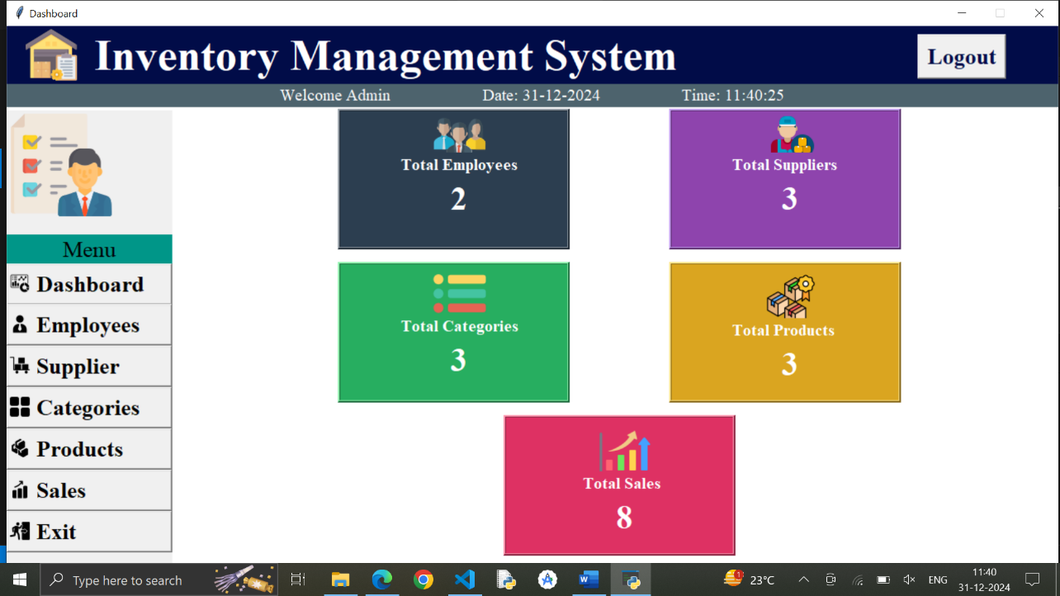
Description: In this dashboard, admin can see employees data, suppliers data, categories data, products data and also see sales

Code:
from tkinter import *
from PIL import ImageTk
import pymysql
from employees import employee_form
from supplier import supplier_form
from category import category_form
from products import product_form
from sales import sales_form

import os
from datetime import datetime # Import datetime module

# GUI Part
window = Tk()
window.title("Dashboard")
window.geometry("1270x668+0+0")
window.resizable(0, 0)
window.config(bg='white')

def redirect_to_login():
window.destroy() # Close the current window
os.system('python logine.py')
def exit_program():
window.quit()
# Load background image
bg_image = PhotoImage(file='inventory.png')

# Title label with image and text
titleLabel = Label(window, image=bg_image, compound=LEFT, text="Inventory Management System",
font=("times new roman", 40, "bold"), bg="#010c48", fg="white", anchor="w", padx=20)
titleLabel.place(x=0, y=0, relwidth=1)

logoutButton = Button(window, text="Logout", font=('times new roman', 20, 'bold'), fg='#010c48', command=redirect_to_login, cursor="hand2")
logoutButton.place(x=1100, y=10)

subtitleLabel = Label(window, text="Welcome Admin\t\t Date:15-11-2024\t\t Time:9:00:00pm", font=('times new roman', 15), bg='#4d636d', fg='white')
subtitleLabel.place(x=0, y=70, relwidth=1)

# Function to update date and time dynamically

# Call update_date_time() to start updating the label
update_date_time()

leftFrame = Frame(window)
leftFrame.place(x=0, y=102, width=200, height=555)

logoImage = PhotoImage(file='logo.png')
imageLabel = Label(leftFrame, image=logoImage)
imageLabel.grid(row=0, column=0)

menuLabel = Label(leftFrame, text="Menu", font=('times new roman', 20), bg='#009688')
menuLabel.grid(row=1, column=0, pady=10)
menuLabel.place(width=200, y=150)

import os

# Button for Employees
dash_icon = ImageTk.PhotoImage(file='dash.png')
dash_button = Button(leftFrame, image=dash_icon, compound=LEFT, text=" Dashboard", font=('times new roman', 20, 'bold'), anchor="w", command=lambda: os.system('python dashboard.py'))
dash_button.grid(row=2, column=0, pady=10, padx=10)
dash_button.place(width=200, y=185, height=50)

employee_icon = ImageTk.PhotoImage(file='employee.png')
employee_button = Button(leftFrame, image=employee_icon, compound=LEFT, text=" Employees", font=('times new roman', 20, 'bold'), anchor="w", command=lambda: employee_form(window))
employee_button.grid(row=3, column=0, pady=10, padx=10)
employee_button.place(width=200, y=234, height=50)

# Remaining code for buttons, frames, and labels
# ...

supplier_icon=ImageTk.PhotoImage(file='supplier.png')
supplier_button=Button(leftFrame,image=supplier_icon,compound=LEFT,text=" Supplier",font=('times new roman',20,'bold'),anchor="w",command=lambda :supplier_form(window))
supplier_button.grid(row=3,column=0,pady=10,padx=10)
supplier_button.place(width=200,y=284,height=50)

category_icon=ImageTk.PhotoImage(file='category.png')
category_button=Button(leftFrame,image=category_icon,compound=LEFT,text=" Categories",font=('times new roman',20,'bold'),anchor="w",command=lambda:category_form(window))
category_button.grid(row=5,column=0,pady=10,padx=10)
category_button.place(width=200,y=334,height=50)

products_icon=ImageTk.PhotoImage(file='product.png')
products_button=Button(leftFrame,image=products_icon,compound=LEFT,text=" Products",font=('times new roman',20,'bold'),anchor="w",command=lambda:product_form(window))
products_button.grid(row=6,column=0,pady=10,padx=10)
products_button.place(width=200,y=384,height=50)

sales_icon=ImageTk.PhotoImage(file='sales.png')
sales_button=Button(leftFrame,image=sales_icon,compound=LEFT,text=" Sales",font=('times new roman',20,'bold'),anchor="w",command=lambda:sales_form(window))
sales_button.grid(row=7,column=0,pady=10,padx=10)
sales_button.place(width=200,y=434,height=50)

exit_icon = ImageTk.PhotoImage(file='exit.png')
exit_button = Button(leftFrame, image=exit_icon, compound=LEFT, text=" Exit", font=('times new roman', 20, 'bold'), anchor="w", command=exit_program)
exit_button.grid(row=8, column=0, pady=10, padx=10)
exit_button.place(width=200, y=484, height=50)
try:
conn = pymysql.connect(host='localhost', user='root', password='', database='inventory_system')
cursor = conn.cursor()

# Execute queries to get counts
cursor.execute("SELECT COUNT(*) FROM employee_data")
total_employees = cursor.fetchone()[0]

cursor.execute("SELECT COUNT(*) FROM supplier_data")
total_suppliers = cursor.fetchone()[0]

cursor.execute("SELECT COUNT(*) FROM category_data")
total_categories = cursor.fetchone()[0]

cursor.execute("SELECT COUNT(*) FROM product_data")
total_products = cursor.fetchone()[0]

cursor.execute("SELECT COUNT(*) FROM bills") # Assuming you have a 'sales' table
total_sales = cursor.fetchone()[0]

finally:
if conn:
conn.close()
emp_frame = Frame(window, bg='#2c3e50', bd=3, relief='ridge')
emp_frame.place(x=400, y=100, height=170, width=280)
total_emp_icon = PhotoImage(file='staff.png')
total_emp_icon_label = Label(emp_frame, image=total_emp_icon, bg='#2c3e50')
total_emp_icon_label.grid(row=0, column=0, padx=0)
total_emp_icon_label.place(x=110)
total_emp_label = Label(emp_frame, text="Total Employees", bg='#2c3e50', fg='white', font=('times new roman', 15, 'bold'))
total_emp_label.grid(row=1, column=0, padx=105, pady=10)
total_emp_label.place(x=70, y=50)
total_emp_count_label = Label(emp_frame, text=str(total_employees), bg='#2c3e50', fg='white', font=('times new roman', 30, 'bold'))
total_emp_count_label.grid(row=2, column=0, padx=105, pady=10)
total_emp_count_label.place(x=130, y=80)

sup_frame=Frame(window,bg='#8e44ad',bd=3,relief='ridge')
sup_frame.place(x=800,y=100,height=170,width=280)
total_sup_icon=PhotoImage(file='suppliers.png')
total_sup_icon_label=Label(sup_frame,image=total_sup_icon,bg='#8e44ad')
total_sup_icon_label.grid(row=0,column=0,padx=0)
total_sup_icon_label.place(x=110)
total_sup_label=Label(sup_frame,text="Total Suppliers",bg='#8e44ad',fg='white',font=('times new roman',15,'bold'))
total_sup_label.grid(row=1,column=0,padx=105, pady=10)
total_sup_label.place(x=70,y=50)
total_sup_count_label=Label(sup_frame,text=str(total_suppliers),bg='#8e44ad',fg='white',font=('times new roman',30,'bold'))
total_sup_count_label.grid(row=2,column=0,padx=105, pady=10)
total_sup_count_label.place(x=130,y=80)

cat_frame=Frame(window,bg='#27ae60',bd=3,relief='ridge')
cat_frame.place(x=400,y=285,height=170,width=280)
total_cat_icon=PhotoImage(file='options.png')
total_cat_icon_label=Label(cat_frame,image=total_cat_icon,bg='#27ae60')
total_cat_icon_label.grid(row=0,column=0,padx=0,pady=30)
total_cat_icon_label.place(x=110,y=10)
total_cat_label=Label(cat_frame,text="Total Categories",bg='#27ae60',fg='white',font=('times new roman',15,'bold'))
total_cat_label.grid(row=1,column=0,padx=105, pady=10)
total_cat_label.place(x=70,y=60)
total_cat_count_label=Label(cat_frame,text=str(total_categories),bg='#27ae60',fg='white',font=('times new roman',30,'bold'))
total_cat_count_label.grid(row=2,column=0,padx=105, pady=10)
total_cat_count_label.place(x=130,y=90)

prod_frame=Frame(window,bg='#daa520',bd=3,relief='ridge')
prod_frame.place(x=800,y=285,height=170,width=280)
total_prod_icon=PhotoImage(file='products.png')
total_prod_icon_label=Label(prod_frame,image=total_prod_icon,bg='#daa520')
total_prod_icon_label.grid(row=0,column=0,padx=0)
total_prod_icon_label.place(x=110,y=10)
total_prod_label=Label(prod_frame,text="Total Products",bg='#daa520',fg='white',font=('times new roman',15,'bold'))
total_prod_label.grid(row=1,column=0,padx=105, pady=10)
total_prod_label.place(x=70,y=65)
total_prod_count_label=Label(prod_frame,text=str(total_products),bg='#daa520',fg='white',font=('times new roman',30,'bold'))
total_prod_count_label.grid(row=2,column=0,padx=105, pady=10)
total_prod_count_label.place(x=130,y=95)

sales_frame=Frame(window,bg='#de3163',bd=3,relief='ridge')
sales_frame.place(x=600,y=470,height=170,width=280)
total_sales_icon=PhotoImage(file='trend.png')
total_sales_icon_label=Label(sales_frame,image=total_sales_icon,bg='#de3163')
total_sales_icon_label.grid(row=0,column=0,padx=0)
total_sales_icon_label.place(x=110,y=10)
total_sales_label=Label(sales_frame,text="Total Sales",bg='#de3163',fg='white',font=('times new roman',15,'bold'))
total_sales_label.grid(row=1,column=0,padx=105, pady=10)
total_sales_label.place(x=90,y=65)
total_sales_count_label=Label(sales_frame,text=str(total_sales),bg='#de3163',fg='white',font=('times new roman',30,'bold'))
total_sales_count_label.grid(row=2,column=0,padx=105, pady=10)
total_sales_count_label.place(x=130,y=95)

# Main event loop
window.mainloop()

Manage Employees Page

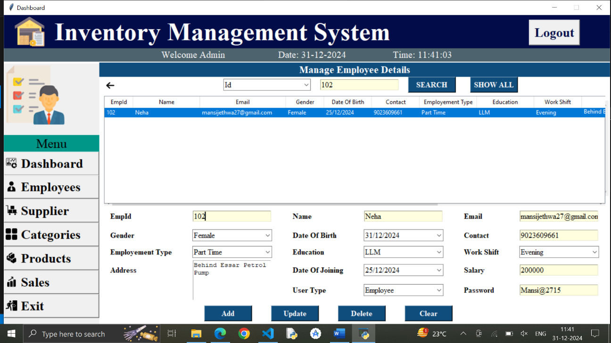
Description: In this page, Admin can manage employees data.

Code:
from tkinter import *
from PIL import ImageTk
from tkinter import ttk
from tkinter import messagebox
from tkcalendar import DateEntry
import mysql.connector
from datetime import date
import re

import re

def employee_form(window):
global back_image,employee_treeview
employee_frame=Frame(window,width=1070,height=567,bg='white')
employee_frame.place(x=200,y=100)
heading_Label=Label(employee_frame,text='Manage Employee Details',font=('times new roman',16,'bold'),bg='#0f4d7d',fg='white')
heading_Label.place(x=0,y=0,relwidth=1)
top_frame=Frame(employee_frame,bg='white')
top_frame.place(x=0,y=30,relwidth=1)
back_image=PhotoImage(file='arrow.png')
back_button = Button(top_frame, image=back_image, bd=0, cursor='hand2',bg='white', command=lambda: employee_frame.place_forget())
back_button.place(x=10,y=5)
search_frame=Frame(top_frame,bg='white')
search_frame.place(x=240)
search_combobox=ttk.Combobox(search_frame,values=('Id','Name','Email'),font=('times new roman',12),state='readonly')
search_combobox.set('Search By')
search_combobox.grid(row=0,column=0,padx=20)
search_entry=Entry(search_frame,font=('times new roman',12),bg='lightyellow')
search_entry.grid(row=0,column=1)
search_button=Button(search_frame,text='SEARCH',width=10,font=('times new roman',12,'bold'),bg="#0f4d7d", fg="white", cursor='hand2',command=lambda :search_employee(search_combobox.get(),search_entry.get()))
search_button.grid(row=0,column=2,padx=20)
show_button=Button(search_frame,text='SHOW ALL',width=10,font=('times new roman',12,'bold'),bg="#0f4d7d", fg="white", cursor='hand2',command=lambda :show_all(search_entry,search_combobox))
show_button.grid(row=0,column=3,padx=10)

# Add the Treeview and scrollbars
horizontal_scrollbar = Scrollbar(top_frame, orient=HORIZONTAL)
vertical_scrollbar = Scrollbar(top_frame, orient=VERTICAL)

# Create the Treeview and link scrollbars
employee_treeview = ttk.Treeview(
top_frame,
columns=(
'empid', 'name', 'email', 'gender', 'dob', 'contact',
'employement_type', 'education', 'work_shift', 'address',
'doj', 'salary', 'usertype'
),
show='headings',
yscrollcommand=vertical_scrollbar.set,
xscrollcommand=horizontal_scrollbar.set
)

# Configure scrollbars to work with the Treeview
horizontal_scrollbar.config(command=employee_treeview.xview)
vertical_scrollbar.config(command=employee_treeview.yview)

# Place Treeview and scrollbars
employee_treeview.place(x=100,y=200,height=200,width=100)
employee_treeview.grid(row=0, column=0, padx=10, pady=40)
vertical_scrollbar.grid(row=0, column=1,sticky='ns')
horizontal_scrollbar.grid(row=1, column=0, sticky='ew', padx=10)

horizontal_scrollbar.place(x=10,y=255,width=1050)
vertical_scrollbar.place(x=1050,y=50,height=200)

# Define Treeview columns and headings
employee_treeview.heading('empid', text='EmpId')
employee_treeview.heading('name', text='Name')
employee_treeview.heading('email', text='Email')
employee_treeview.heading('gender', text='Gender')
employee_treeview.heading('dob', text='Date Of Birth')
employee_treeview.heading('contact', text='Contact')
employee_treeview.heading('employement_type', text='Employement Type')
employee_treeview.heading('education', text='Education')
employee_treeview.heading('work_shift', text='Work Shift')
employee_treeview.heading('address', text='Address')
employee_treeview.heading('doj', text='Date of Joining')
employee_treeview.heading('salary', text='Salary')
employee_treeview.heading('usertype', text='User Type')

employee_treeview.column('empid', width=60)
employee_treeview.column('name', width=140)
employee_treeview.column('email', width=180)
employee_treeview.column('gender', width=80)
employee_treeview.column('dob', width=100)
employee_treeview.column('contact', width=100)
employee_treeview.column('employement_type', width=120)
employee_treeview.column('education', width=120)
employee_treeview.column('work_shift', width=100)
employee_treeview.column('address', width=200)
employee_treeview.column('doj', width=100)
employee_treeview.column('salary', width=140)
employee_treeview.column('usertype', width=120)

treeview_data()

top_frame.grid_rowconfigure(0, weight=1)
top_frame.grid_columnconfigure(0, weight=1)

detail_frame=Frame(employee_frame,bg='white')
detail_frame.place(x=0,y=300)

empid_label=Label(detail_frame,text='EmpId',font=('times new roman',12,'bold'),bg='white')
empid_label.grid(row=0,column=0,padx=20,pady=10,sticky="w")
empid_entry=Entry(detail_frame,font=('times new roman',12),bg='lightyellow')
empid_entry.grid(row=0,column=1,padx=20,pady=10)

name_label=Label(detail_frame,text='Name',font=('times new roman',12,'bold'),bg='white')
name_label.grid(row=0,column=2,padx=20,pady=10,sticky="w")
name_entry=Entry(detail_frame,font=('times new roman',12),bg='lightyellow')
name_entry.grid(row=0,column=3,padx=20,pady=10)

email_label=Label(detail_frame,text='Email',font=('times new roman',12,'bold'),bg='white')
email_label.grid(row=0,column=4,padx=20,pady=10,sticky="w")
email_entry=Entry(detail_frame,font=('times new roman',12),bg='lightyellow')
email_entry.grid(row=0,column=5,padx=20,pady=10)

gender_label=Label(detail_frame,text='Gender',font=('times new roman',12,'bold'),bg='white')
gender_label.grid(row=1,column=0,padx=20,pady=5,sticky="w")
gender_combobox=ttk.Combobox(detail_frame,values=('Male','Female'),font=('times new roman',12),width=18,state='readonly')
gender_combobox.set('Select Gender')
gender_combobox.grid(row=1,column=1,padx=20,pady=5)

dob_label=Label(detail_frame,text='Date Of Birth',font=('times new roman',12,'bold'),bg='white')
dob_label.grid(row=1,column=2,padx=20,pady=5,sticky="w")
dob_date_entry=DateEntry(detail_frame,width=18,font=('times new roman',12),state='readonly',date_pattern='dd/mm/yyyy')
dob_date_entry.grid(row=1,column=3,padx=20,pady=5)

contact_label=Label(detail_frame,text='Contact',font=('times new roman',12,'bold'),bg='white')
contact_label.grid(row=1,column=4,padx=20,pady=5,sticky="w")
contact_entry=Entry(detail_frame,font=('times new roman',12),bg='lightyellow')
contact_entry.grid(row=1,column=5,padx=20,pady=5)

employement_type_label=Label(detail_frame,text='Employement Type',font=('times new roman',12,'bold'),bg='white')
employement_type_label.grid(row=2,column=0,padx=20,pady=5,sticky="w")
employement_type_combobox=ttk.Combobox(detail_frame,values=('Full Time','Part Time','Casual','Contract','Intern'),font=('times new roman',12),width=18,state='readonly')
employement_type_combobox.set('Select Employement Type')
employement_type_combobox.grid(row=2,column=1,padx=20,pady=5)

education_label=Label(detail_frame,text='Education',font=('times new roman',12,'bold'),bg='white')
education_label.grid(row=2,column=2,padx=20,pady=5,sticky="w")
education_options=['B.Tech','B.Com','M.Tech','B.Sc','M.Sc','BBA','MBA','LLB','LLM','B.Arch','M.Arch']
education_combobox=ttk.Combobox(detail_frame,values=education_options,font=('times new roman',12),width=18,state='readonly')
education_combobox.set('Select Education')
education_combobox.grid(row=2,column=3,padx=20,pady=5)

work_shift_label=Label(detail_frame,text='Work Shift',font=('times new roman',12,'bold'),bg='white')
work_shift_label.grid(row=2,column=4,padx=20,pady=5,sticky="w")
work_shift_combobox=ttk.Combobox(detail_frame,values=('Morning','Evening','Night'),font=('times new roman',12),width=18,state='readonly')
work_shift_combobox.set('Select Work Shift')
work_shift_combobox.grid(row=2,column=5,padx=20,pady=5)

address_label=Label(detail_frame,text='Address',font=('times new roman',12,'bold'),bg='white')
address_label.grid(row=3,column=0,padx=20,pady=5,sticky='w')
address_text=Text(detail_frame,width=20,height=5)
address_text.grid(row=3,column=1,rowspan=2)

doj_label=Label(detail_frame,text='Date Of Joining',font=('times new roman',12,'bold'),bg='white')
doj_label.grid(row=3,column=2,padx=20,pady=5,sticky="w")
doj_date_entry=DateEntry(detail_frame,width=18,font=('times new roman',12),state='readonly',date_pattern='dd/mm/yyyy')
doj_date_entry.grid(row=3,column=3,padx=20,pady=5)

usertype_label=Label(detail_frame,text='User Type',font=('times new roman',12,'bold'),bg='white')
usertype_label.grid(row=4,column=2,padx=20,pady=5,sticky="w")
usertype_combobox=ttk.Combobox(detail_frame,values=('Admin','Employee'),font=('times new roman',12),width=18,state='readonly')
usertype_combobox.set('Select User Type')
usertype_combobox.grid(row=4,column=3,padx=20,pady=5)

salary_label=Label(detail_frame,text='Salary',font=('times new roman',12,'bold'),bg='white')
salary_label.grid(row=3,column=4,padx=20,pady=5,sticky="w")
salary_entry=Entry(detail_frame,font=('times new roman',12),bg='lightyellow')
salary_entry.grid(row=3,column=5,padx=20,pady=5)

password_label=Label(detail_frame,text='Password',font=('times new roman',12,'bold'),bg='white')
password_label.grid(row=4,column=4,padx=20,pady=5,sticky="w")
password_entry=Entry(detail_frame,font=('times new roman',12),bg='lightyellow')
password_entry.grid(row=4,column=5,padx=20,pady=5)

button_frame=Frame(employee_frame,bg='white')
button_frame.place(x=200,y=510)
ad_button=Button(button_frame,text='Add',font=('times new roman',12,'bold') ,width=10,cursor='hand2',fg='white',bg='#0f4d7d',command=lambda :add_employee(empid_entry.get(),name_entry.get(),email_entry.get(),gender_combobox.get(),dob_date_entry.get(),contact_entry.get(),employement_type_combobox.get(),education_combobox.get(),work_shift_combobox.get(),address_text.get(1.0,END),doj_date_entry.get(),salary_entry.get(),usertype_combobox.get(),password_entry.get()))
ad_button.grid(row=0,column=0,padx=20)

update_button=Button(button_frame,text='Update',font=('times new roman',12,'bold') ,width=10,cursor='hand2',fg='white',bg='#0f4d7d',command=lambda :update_employee(empid_entry.get(),name_entry.get(),email_entry.get(),gender_combobox.get(),dob_date_entry.get(),contact_entry.get(),employement_type_combobox.get(),education_combobox.get(),work_shift_combobox.get(),address_text.get(1.0,END),doj_date_entry.get(),salary_entry.get(),usertype_combobox.get(),password_entry.get()))
update_button.grid(row=0,column=1,padx=20)

delete_button=Button(button_frame,text='Delete',font=('times new roman',12,'bold') ,width=10,cursor='hand2',fg='white',bg='#0f4d7d',command=lambda :delete_employee(empid_entry.get(),))
delete_button.grid(row=0,column=2,padx=20)

clear_button=Button(button_frame,text='Clear',font=('times new roman',12,'bold') ,width=10,cursor='hand2',fg='white',bg='#0f4d7d',command=lambda :clear_fields(empid_entry,name_entry,email_entry,dob_date_entry,gender_combobox,contact_entry,employement_type_combobox,education_combobox,work_shift_combobox,address_text,doj_date_entry,salary_entry,usertype_combobox,password_entry,True))
clear_button.grid(row=0,column=3,padx=20)
employee_treeview.bind('<ButtonRelease-1>',lambda event:select_data(event,empid_entry,name_entry,email_entry,dob_date_entry,gender_combobox,contact_entry,employement_type_combobox,education_combobox,work_shift_combobox,address_text,doj_date_entry,salary_entry,usertype_combobox,password_entry))

Manage Supplier Page

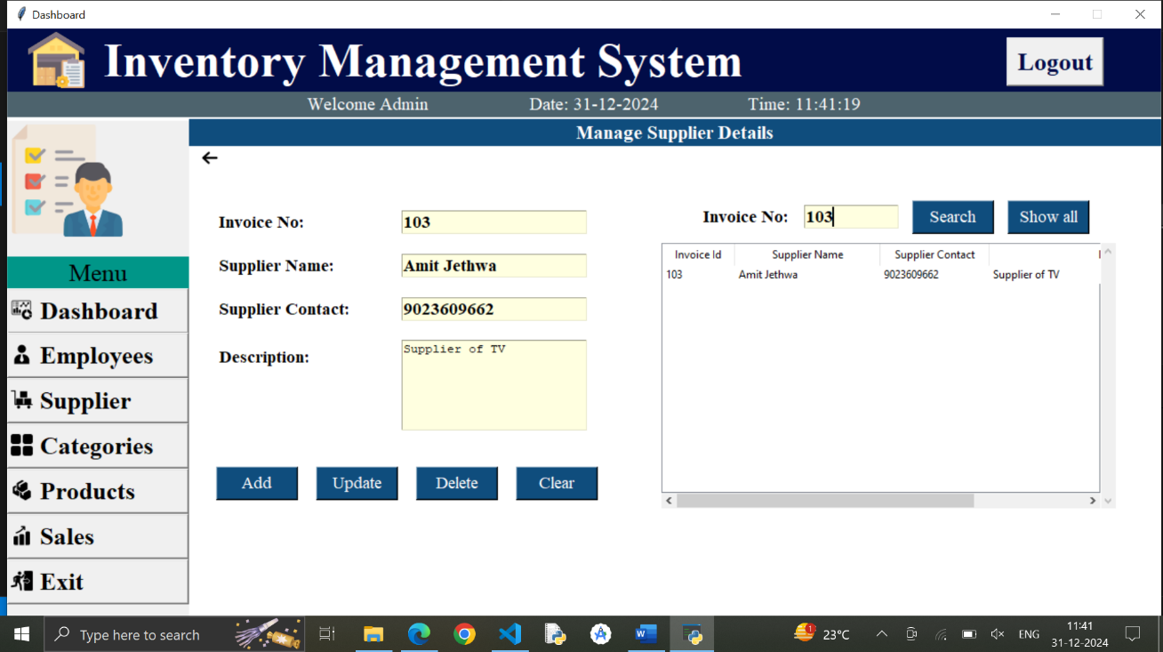
Description: In this page, admin an manage supplier data like supplier name,contact,etc.

Code:
from tkinter import *
from PIL import ImageTk
from tkinter import ttk
from tkinter import messagebox
from tkcalendar import DateEntry
import mysql.connector
from datetime import date

def validate_inputs(invoice, name, contact, description):
"""
Validates the inputs for the supplier form.
"""
if not invoice.isnumeric():
messagebox.showerror("Error", "Invoice must be a numeric value.")
return False
if not name.strip():
messagebox.showerror("Error", "Supplier name is required.")
return False
if not all(x.isalpha() or x.isspace() for x in name):
messagebox.showerror("Error", "Supplier name must contain only alphabetic characters and spaces.")
return False
if not contact.strip():
messagebox.showerror("Error", "Supplier contact is required.")
return False
if not contact.isdigit() or len(contact) != 10:
messagebox.showerror("Error", "Supplier contact must be a 10-digit number.")
return False
if not description.strip():
messagebox.showerror("Error", "Description is required.")
return False
return True
def supplier_form(window):
global back_image
supplier_frame=Frame(window,width=1070,height=567,bg='white')
supplier_frame.place(x=200,y=100)

heading_Label=Label(supplier_frame,text='Manage Supplier Details',font=('times new roman',16,'bold'),bg='#0f4d7d',fg='white')
heading_Label.place(x=0,y=0,relwidth=1)

back_image=PhotoImage(file='arrow.png')
back_button = Button(supplier_frame, image=back_image, bd=0, cursor='hand2',bg='white', command=lambda: supplier_frame.place_forget())
back_button.place(x=10,y=30)

left_frame=Frame(supplier_frame,bg='white')
left_frame.place(x=10,y=100)

invoice_label=Label(left_frame,text='Invoice No:',font=('times new roman',14,'bold'),bg='white')
invoice_label.grid(row=0,column=0,padx=20,sticky="w")
invoice_entry=Entry(left_frame,font=('times new roman',14,'bold'),bg='lightyellow')
invoice_entry.grid(row=0,column=1)

name_label=Label(left_frame,text='Supplier Name:',font=('times new roman',14,'bold'),bg='white')
name_label.grid(row=1,column=0,padx=20,pady=20,sticky="w")
name_entry=Entry(left_frame,font=('times new roman',14,'bold'),bg='lightyellow')
name_entry.grid(row=1,column=1)

contact_label=Label(left_frame,text='Supplier Contact:',font=('times new roman',14,'bold'),bg='white')
contact_label.grid(row=2,column=0,padx=20,sticky="w")
contact_entry=Entry(left_frame,font=('times new roman',14,'bold'),bg='lightyellow')
contact_entry.grid(row=2,column=1)

description_label=Label(left_frame,text='Description:',font=('times new roman',14,'bold'),bg='white')
description_label.grid(row=3,column=0,padx=20,sticky="nw",pady=25)
description_text=Text(left_frame,width=25,height=6,bg='lightyellow')
description_text.grid(row=3,column=1,pady=20)

buttonFrame=Frame(left_frame,bg='white')
buttonFrame.grid(row=4,columnspan=2,pady=20)

# Assuming you have a frame or container for buttons
add_button = Button(buttonFrame, text='Add', font=('times new roman', 14), width=8, cursor='hand2', fg='white', bg='#0f4d7d',
command=lambda: add_supplier(invoice_entry.get(), name_entry.get(), contact_entry.get(), description_text.get(1.0, END).strip(), treeview,invoice_entry, name_entry, contact_entry, description_text))
add_button.grid(row=0, column=0, padx=20)

# Create the Update button and bind it to the update_supplier function
update_button = Button(buttonFrame, text='Update', font=('times new roman', 14), width=8, cursor='hand2', fg='white', bg='#0f4d7d',
command=lambda: update_supplier(
invoice_entry.get(),
name_entry.get(),
contact_entry.get(),
description_text.get("1.0", "end-1c"),
treeview,
invoice_entry,
name_entry,
contact_entry,
description_text
))

update_button.grid(row=0, column=1)

delete_button = Button(buttonFrame, text='Delete', font=('times new roman', 14), width=8, cursor='hand2', fg='white', bg='#0f4d7d',
command=lambda: delete_supplier(treeview,invoice_entry, name_entry, contact_entry, description_text))
delete_button.grid(row=0, column=2, padx=20)

cancel_button = Button(buttonFrame, text='Clear', font=('times new roman', 14), width=8, cursor='hand2', fg='white', bg='#0f4d7d',
command=lambda: clear(invoice_entry, name_entry, contact_entry, description_text))
cancel_button.grid(row=0, column=3)

right_frame=Frame(supplier_frame,bg='white')
right_frame.place(x=520,y=80,width=500,height=350)

search_frame=Frame(right_frame,bg='white')
search_frame.pack(pady=10)

num_label=Label(search_frame,text='Invoice No:',font=('times new roman',14,'bold'),bg='white')
num_label.grid(row=0,column=0,padx=15,sticky="w")
search_entry=Entry(search_frame,font=('times new roman',14,'bold'),bg='lightyellow',width=10)
search_entry.grid(row=0,column=1)

search_button = Button(search_frame, text='Search', font=('times new roman', 14), width=8, cursor='hand2', fg='white', bg='#0f4d7d',
command=lambda: search_supplier(search_entry, treeview))
search_button.grid(row=0, column=2, padx=15)

show_button=Button(search_frame,text='Show all',font=('times new roman',14) ,width=8,cursor='hand2',fg='white',bg='#0f4d7d',command=lambda: show_all(treeview,search_entry))
show_button.grid(row=0,column=3)

scrolly=Scrollbar(right_frame,orient=VERTICAL)
scrollx=Scrollbar(right_frame,orient=HORIZONTAL)
treeview=ttk.Treeview(right_frame,column=('invoice','name','contact','description'),show='headings',yscrollcommand=scrolly.set,xscrollcommand=scrollx.set)
scrolly.pack(side=RIGHT,fill=Y)
scrollx.pack(side=BOTTOM,fill=X)
scrollx.config(command=treeview.xview)
scrolly.config(command=treeview.yview)
treeview.pack(fill=BOTH,expand=1)
treeview.heading('invoice',text='Invoice Id')
treeview.heading('name',text='Supplier Name')
treeview.heading('contact',text='Supplier Contact')
treeview.heading('description',text='Description')

treeview.column('invoice',width=80)
treeview.column('name',width=160)
treeview.column('contact',width=120)
treeview.column('description',width=300)

treeview_data(treeview)
treeview.bind('<ButtonRelease-1>',lambda event:select_data(event,invoice_entry,name_entry,contact_entry,description_text,treeview))

Manage Categories Page

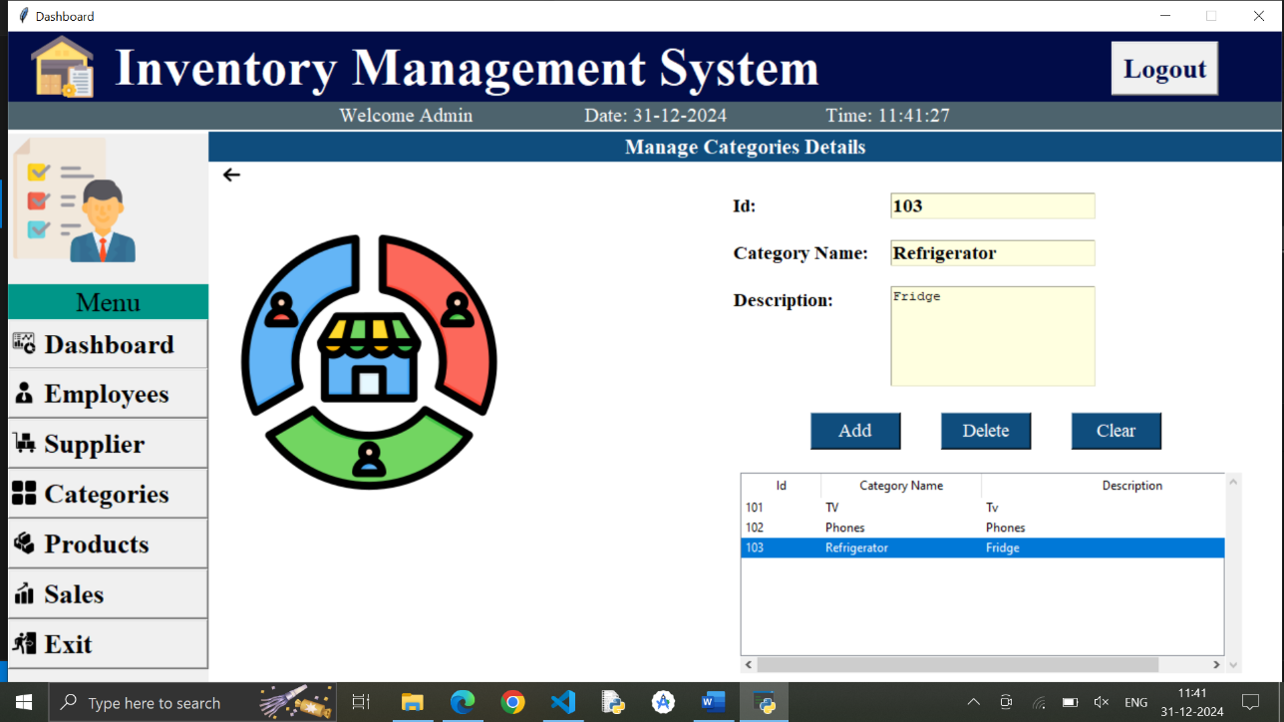
Description: In this page, admin can manage categories data like category name and description.
Code:
from tkinter import *
from PIL import ImageTk
from tkinter import ttk
from tkinter import messagebox
from tkcalendar import DateEntry
import mysql.connector
from datetime import date

# Function to connect to the database and set up the necessary table
# Function to connect to the database and set up the necessary table
def connect_database():
mydb = mysql.connector.connect(host="localhost", user="root", password="")
mycursor = mydb.cursor()
mycursor.execute("CREATE DATABASE IF NOT EXISTS inventory_system")
mycursor.execute("USE inventory_system")
mycursor.execute("CREATE TABLE IF NOT EXISTS category_data (id INT PRIMARY KEY,name VARCHAR(100),description TEXT)")
print("Database and Category Table are ready.")
return mycursor
connect_database()
# Function to clear the input fields
# Function to clear the input fields
def clear(id_entry, category_name_entry, description_text):
id_entry.delete(0, END)
category_name_entry.delete(0, END)
description_text.delete(1.0, END)

# Function to load data into the Treeview
def category_form(window):
global back_image, logo

# Frame for category management
category_frame = Frame(window, width=1070, height=567, bg='white')
category_frame.place(x=200, y=100)

heading_Label = Label(category_frame, text='Manage Categories Details', font=('times new roman', 16, 'bold'), bg='#0f4d7d', fg='white')
heading_Label.place(x=0, y=0, relwidth=1)

back_image = PhotoImage(file='arrow.png')
back_button = Button(category_frame, image=back_image, bd=0, cursor='hand2', bg='white', command=lambda: category_frame.place_forget())
back_button.place(x=10, y=30)

logo = PhotoImage(file='cat4.png')
label = Label(category_frame, image=logo, bg="white")
label.place(x=30, y=100)

details_frame = Frame(category_frame, bg="white")
details_frame.place(x=500, y=60)

id_label = Label(details_frame, text='Id:', font=('times new roman', 14, 'bold'), bg='white')
id_label.grid(row=0, column=0, padx=20, sticky="w")
id_entry = Entry(details_frame, font=('times new roman', 14, 'bold'), bg='lightyellow')
id_entry.grid(row=0, column=1)

category_name_label = Label(details_frame, text='Category Name:', font=('times new roman', 14, 'bold'), bg='white')
category_name_label.grid(row=1, column=0, padx=20, sticky="w")
category_name_entry = Entry(details_frame, font=('times new roman', 14, 'bold'), bg='lightyellow')
category_name_entry.grid(row=1, column=1, pady=20)

description_label = Label(details_frame, text='Description:', font=('times new roman', 14, 'bold'), bg='white')
description_label.grid(row=2, column=0, padx=20, sticky="nw")
description_text = Text(details_frame, width=25, height=6, bg='lightyellow')
description_text.grid(row=2, column=1)

button_frame = Frame(category_frame, bg='white')
button_frame.place(x=580, y=280)

add_button = Button(button_frame, text='Add', font=('times new roman', 14), width=8, cursor='hand2', fg='white', bg='#0f4d7d',
command=lambda: add_category(id_entry.get(),category_name_entry.get(), description_text.get(1.0, END), treeview, id_entry, category_name_entry, description_text))
add_button.grid(row=0, column=0, padx=20)

delete_button = Button(button_frame, text='Delete', font=('times new roman', 14), width=8, cursor='hand2', fg='white', bg='#0f4d7d',
command=lambda: delete_category(treeview))
delete_button.grid(row=0, column=1, padx=20)

clear_button = Button(button_frame, text='Clear', font=('times new roman', 14), width=8, cursor='hand2', fg='white', bg='#0f4d7d',
command=lambda: clear(id_entry, category_name_entry, description_text))
clear_button.grid(row=0, column=2, padx=20)

treeview_frame = Frame(category_frame, bg='white')
treeview_frame.place(x=530, y=340, height=200, width=500)

scrolly = Scrollbar(treeview_frame, orient=VERTICAL)
scrollx = Scrollbar(treeview_frame, orient=HORIZONTAL)
treeview = ttk.Treeview(treeview_frame, column=('id', 'name', 'description'), show='headings',
yscrollcommand=scrolly.set, xscrollcommand=scrollx.set)
scrolly.pack(side=RIGHT, fill=Y)
scrollx.pack(side=BOTTOM, fill=X)
scrollx.config(command=treeview.xview)
scrolly.config(command=treeview.yview)
treeview.pack(fill=BOTH, expand=1)

treeview.heading('id', text='Id')
treeview.heading('name', text='Category Name')
treeview.heading('description', text='Description')

treeview.column('id', width=80)
treeview.column('name', width=160)
treeview.column('description', width=300)

treeview_data(treeview)
treeview.bind('<ButtonRelease-1>', lambda event: select_data(event, id_entry, category_name_entry, description_text, treeview))

Manage Products Page

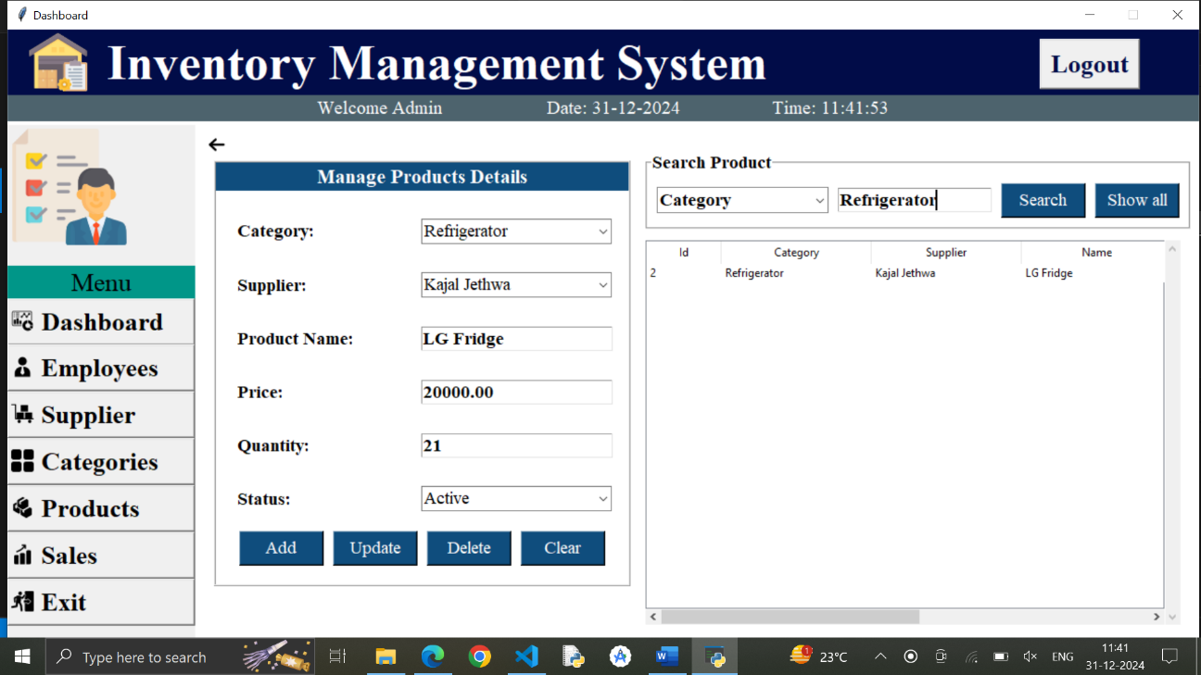
Description: In this page, admin can manage products data like product’s category, supplier, product name, price, quantity,etc.

Code:
from tkinter import *
from PIL import ImageTk
from tkinter import ttk
from tkinter import messagebox
from tkcalendar import DateEntry
import mysql.connector
from datetime import date

def validate_update_input(category, supplier, name, price, quantity, status):
"""Validates the input fields for product updates."""
if category == 'Select':
messagebox.showerror('Error', 'Please select a Category.')
return False
if supplier == 'Select':
messagebox.showerror('Error', 'Please select a Supplier.')
return False
if not name:
messagebox.showerror('Error', 'Please enter a Product Name.')
return False
try:
float(price)
except ValueError:
messagebox.showerror('Error', 'Price must be a number.')
return False
try:
int(quantity)
if int(quantity) < 0:
messagebox.showerror('Error', 'Quantity must be a positive integer.')
return False
except ValueError:
messagebox.showerror('Error', 'Quantity must be an integer.')
return False
if status == 'Select':
messagebox.showerror('Error', 'Please select a Status.')
return False
return True

def validate_input(category, supplier, name, price, quantity, status):
"""Validates the input fields."""
if category == 'Select':
messagebox.showerror('Error', 'Please select a Category.')
return False
if supplier == 'Select':
messagebox.showerror('Error', 'Please select a Supplier.')
return False
if not name:
messagebox.showerror('Error', 'Please enter a Product Name.')
return False
try:
float(price)
except ValueError:
messagebox.showerror('Error', 'Price must be a number.')
return False
try:
int(quantity)
if int(quantity) < 0:
messagebox.showerror('Error', 'Quantity must be a positive integer.')
return False
except ValueError:
messagebox.showerror('Error', 'Quantity must be an integer.')
return False
if status == 'Select':
messagebox.showerror('Error', 'Please select a Status.')
return False
return True

# Add the following functions outside the `product_form` function:
def product_form(window):
global back_image
product_frame=Frame(window,width=1070,height=567,bg='white')
product_frame.place(x=200,y=100)

back_image = PhotoImage(file='arrow.png')
back_button = Button(product_frame, image=back_image, bd=0, cursor='hand2', bg='white', command=lambda: product_frame.place_forget())
back_button.place(x=10, y=10)

left_frame=Frame(product_frame,bg='white',bd=2,relief=RIDGE)
left_frame.place(x=20,y=40)

heading_Label = Label(left_frame, text='Manage Products Details', font=('times new roman', 16, 'bold'), bg='#0f4d7d', fg='white')
heading_Label.grid(row=0,columnspan=2,sticky="we")

category_label = Label(left_frame, text='Category:', font=('times new roman', 14, 'bold'), bg='white')
category_label.grid(row=1, column=0, padx=20, sticky="w")
category_combobox=ttk.Combobox(left_frame,font=('times new roman', 14),width=20,state='readonly')
category_combobox.grid(row=1,column=1,pady=30)
category_combobox.set('Select')

supplier_label = Label(left_frame, text='Supplier:', font=('times new roman', 14, 'bold'), bg='white')
supplier_label.grid(row=2, column=0, padx=20, sticky="w")
supplier_combobox=ttk.Combobox(left_frame,font=('times new roman', 14),width=20,state='readonly')
supplier_combobox.grid(row=2,column=1)
supplier_combobox.set('Select')

name_label = Label(left_frame, text='Product Name:', font=('times new roman', 14, 'bold'), bg='white')
name_label.grid(row=3, column=0, padx=20, sticky="w")
name_entry = Entry(left_frame, font=('times new roman', 14, 'bold'), bg='white')
name_entry.grid(row=3, column=1,pady=30)

price_label = Label(left_frame, text='Price:', font=('times new roman', 14, 'bold'), bg='white')
price_label.grid(row=4, column=0, padx=20, sticky="w")
price_entry = Entry(left_frame, font=('times new roman', 14, 'bold'), bg='white')
price_entry.grid(row=4, column=1)

quantity_label = Label(left_frame, text='Quantity:', font=('times new roman', 14, 'bold'), bg='white')
quantity_label.grid(row=5, column=0, padx=20, sticky="w")
quantity_entry = Entry(left_frame, font=('times new roman', 14, 'bold'), bg='white')
quantity_entry.grid(row=5, column=1,pady=30)

status_label = Label(left_frame, text='Status:', font=('times new roman', 14, 'bold'), bg='white')
status_label.grid(row=6, column=0, padx=20, sticky="w")
status_combobox=ttk.Combobox(left_frame,values=('Active','Inactive'),font=('times new roman', 14),width=20,state='readonly')
status_combobox.grid(row=6,column=1)
status_combobox.set('Select')

button_frame=Frame(left_frame,bg="white")
button_frame.grid(row=7,columnspan=2,padx=20)

add_button = Button(button_frame,text='Add',font=('times new roman', 14),width=8,cursor='hand2',fg='white',bg='#0f4d7d',command=lambda: add_product(category_combobox.get(),supplier_combobox.get(),name_entry.get(),price_entry.get(),quantity_entry.get(),status_combobox.get(),treeview))
add_button.grid(row=0, column=0, padx=5)

update_button = Button(button_frame, text='Update', font=('times new roman', 14), width=8, cursor='hand2', fg='white', bg='#0f4d7d',command=lambda: update_product(category_combobox.get(), supplier_combobox.get(), name_entry.get(),
price_entry.get(), quantity_entry.get(), status_combobox.get(), treeview))
update_button.grid(row=0, column=1, padx=5)

delete_button = Button(button_frame, text='Delete', font=('times new roman', 14), width=8, cursor='hand2', fg='white', bg='#0f4d7d',
command=lambda: delete_product(treeview))
delete_button.grid(row=0, column=2, padx=5, pady=20)

clear_button = Button(button_frame, text='Clear', font=('times new roman', 14), width=8, cursor='hand2', fg='white', bg='#0f4d7d',
command=lambda: clear_form(category_combobox, supplier_combobox, name_entry, price_entry, quantity_entry, status_combobox))
clear_button.grid(row=0, column=3, padx=5, pady=20)

search_frame=LabelFrame(product_frame,text='Search Product',font=('times new roman',14,'bold'), bg='white')
search_frame.place(x=480,y=30)

search_combobox=ttk.Combobox(search_frame,values=('Category','Supplier','Name','Status'),state='readonly',width=16,font=('times new roman',14,'bold'))
search_combobox.grid(row=0,column=0,padx=10)
search_combobox.set('Search By')

search_entry = Entry(search_frame, font=('times new roman', 14, 'bold'), bg='white',width=16)
search_entry.grid(row=0, column=1)

search_button = Button(search_frame, text='Search', font=('times new roman', 14), width=8, cursor='hand2', fg='white', bg='#0f4d7d',
command=lambda: search_product(treeview, search_combobox.get(), search_entry.get()))
search_button.grid(row=0, column=2, padx=(10, 0), pady=10)

show_button = Button(search_frame, text='Show all', font=('times new roman', 14), width=8, cursor='hand2', fg='white', bg='#0f4d7d',
command=lambda: show_all_products(treeview))
show_button.grid(row=0, column=3, padx=10)

treeview_frame=Frame(product_frame)
treeview_frame.place(x=480,y=125,width=570,height=410)

scrolly = Scrollbar(treeview_frame, orient=VERTICAL)
scrollx = Scrollbar(treeview_frame, orient=HORIZONTAL)
treeview = ttk.Treeview(treeview_frame, column=('id','category', 'supplier', 'name','price','quantity','status'), show='headings',
yscrollcommand=scrolly.set, xscrollcommand=scrollx.set)
scrolly.pack(side=RIGHT, fill=Y)
scrollx.pack(side=BOTTOM, fill=X)
scrollx.config(command=treeview.xview)
scrolly.config(command=treeview.yview)
treeview.pack(fill=BOTH, expand=1)

treeview.heading('id', text='Id')
treeview.heading('category', text='Category')
treeview.heading('supplier', text='Supplier')
treeview.heading('name', text='Name')
treeview.heading('price', text='Price')
treeview.heading('quantity', text='Quantity')
treeview.heading('status', text='Status')

treeview.column('id', width=80)
treeview.column('category', width=160)
treeview.column('supplier', width=160)
treeview.column('name', width=160)
treeview.column('price', width=160)
treeview.column('quantity', width=160)
treeview.column('status', width=160)
treeview.bind(
"<ButtonRelease-1>",
lambda event: select_item(
treeview, category_combobox, supplier_combobox,
name_entry, price_entry, quantity_entry, status_combobox
)
)

# Fetch initial data for the Treeview
fetch_supplier_category(category_combobox, supplier_combobox)
treeview_data(treeview)

Manage Sales

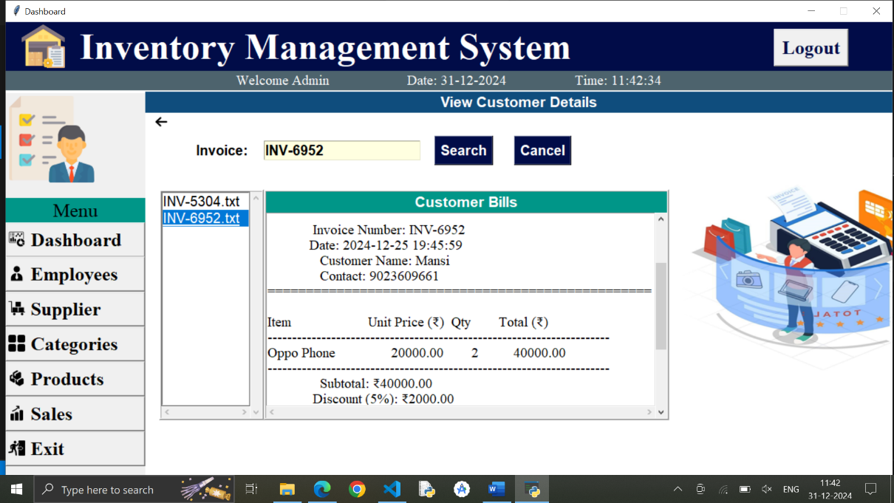
Description: In this page, admin can manage sales data.

Code:
from tkinter import *
from PIL import Image, ImageTk
from tkinter import messagebox
import os

def show(window, sales_list):
sales_list.delete(0, END)
# List files in 'bills' directory and filter for '.txt' files
for i in os.listdir('bills'):
if i.split('.')[-1] == 'txt': # Only show .txt files
sales_list.insert(END, i)

def get_data(event, bill_area):
# Get the widget from the event
sales_list = event.widget
# Get the selected index
index_ = sales_list.curselection() # Check if a selection is made
filename = sales_list.get(index_[0])
print("Selected file:", filename)
bill_area.delete('1.0', END)
filepath = f'bills/{filename}' # Update to correct path
try:
with open(filepath, 'r', encoding='utf-8') as fp:
bill_area.insert(END, fp.read())
except Exception as e:
messagebox.showerror("Error", f"Could not open the bill: {e}")

def sales_form(window):
global back_image, bill_photo

sales_frame = Frame(window, width=1070, height=567, bg='white')
sales_frame.place(x=200, y=100)

heading_Label = Label(sales_frame, text='View Customer Details', font=('Arial Unicode MS', 16, 'bold'), bg='#0f4d7d', fg='white')
heading_Label.place(x=0, y=0, relwidth=1)

back_image = PhotoImage(file='arrow.png')
back_button = Button(sales_frame, image=back_image, bd=0, cursor='hand2', bg='white', command=lambda: sales_frame.place_forget())
back_button.place(x=10, y=30)

detail_frame = Frame(sales_frame, bg='white')
detail_frame.place(x=50, y=50)

id_label = Label(detail_frame, text='Invoice:', font=('Arial Unicode MS', 15, 'bold'), bg='white')
id_label.grid(row=0, column=0, padx=20, sticky="w")
id_entry = Entry(detail_frame, font=('Arial Unicode MS', 15, 'bold'), bg='lightyellow')
id_entry.grid(row=0, column=1, pady=20)

# Search Button
def search_invoice():
invoice_id = id_entry.get().strip()
if not invoice_id:
messagebox.showerror("Error", "Please enter an invoice ID!")
return

# Check if the invoice file exists in the 'bills' directory
filepath = f'bills/{invoice_id}.txt'
if os.path.exists(filepath):
with open(filepath, 'r') as fp:
bill_area.delete('1.0', END)
bill_area.insert(END, fp.read())
else:
messagebox.showinfo("Not Found", f"Invoice '{invoice_id}' not found!")

btn_search = Button(
detail_frame,
text="Search",
font=('Arial Unicode MS', 15, 'bold'),
bg="#010c48",
fg="white",
cursor="hand2",
command=search_invoice
)
btn_search.grid(row=0, column=2, padx=20)

# Cancel Button
def cancel_search():
id_entry.delete(0, END) # Clear the invoice entry field
bill_area.delete('1.0', END) # Clear the bill display area
show(window, sales_list) # Reload the sales list

btn_cancel = Button(
detail_frame,
text="Cancel",
font=('Arial Unicode MS', 15, 'bold'),
bg="#010c48",
fg="white",
cursor="hand2",
command=cancel_search
)
btn_cancel.grid(row=0, column=3, padx=10)

salesd_frame = Frame(sales_frame, bd=3, relief=RIDGE)
salesd_frame.place(x=20, y=140, width=150, height=330)

# Adding both vertical and horizontal scrollbars for sales_list
scrolly = Scrollbar(salesd_frame, orient=VERTICAL)
scrollx = Scrollbar(salesd_frame, orient=HORIZONTAL)
sales_list = Listbox(salesd_frame, font=('Arial Unicode MS', 15), bg="white", yscrollcommand=scrolly.set, xscrollcommand=scrollx.set)
scrolly.pack(side=RIGHT, fill=Y)
scrollx.pack(side=BOTTOM, fill=X) # Position the horizontal scrollbar at the bottom
scrolly.config(command=sales_list.yview)
scrollx.config(command=sales_list.xview)
sales_list.pack(fill=BOTH, expand=1)

# Bind the listbox selection to the get_data function
sales_list.bind("<ButtonRelease-1>", lambda event: get_data(event, bill_area))

bill_frame = Frame(sales_frame, bd=3, relief=RIDGE)
bill_frame.place(x=170, y=140, width=580, height=330)

heading_Label = Label(bill_frame, text='Customer Bills', font=('Arial Unicode MS', 16, 'bold'), bg='#009688', fg='white')
heading_Label.pack(side=TOP, fill=X)

# Adding both vertical and horizontal scrollbars for bill_area
scrolly2 = Scrollbar(bill_frame, orient=VERTICAL)
scrollx2 = Scrollbar(bill_frame, orient=HORIZONTAL)
bill_area = Text(bill_frame, font=('times new roman', 15), bg="white", yscrollcommand=scrolly2.set, xscrollcommand=scrollx2.set, wrap="word")
scrolly2.pack(side=RIGHT, fill=Y)
scrollx2.pack(side=BOTTOM, fill=X) # Position the horizontal scrollbar at the bottom
scrolly2.config(command=bill_area.yview)
scrollx2.config(command=bill_area.xview)
bill_area.pack(fill=BOTH, expand=1)

bill_photo = Image.open('logobill.jpg') # Open the image
bill_photo = bill_photo.resize((450, 300)) # Resize the image
bill_photo = ImageTk.PhotoImage(bill_photo)

lbl_image = Label(sales_frame, image=bill_photo, bd=0)
lbl_image.image = bill_photo # Persist the image reference
lbl_image.place(x=755, y=110)

show(window, sales_list) # Pass `sales_list` to `show` to load the bills

Employee Side

Login Page

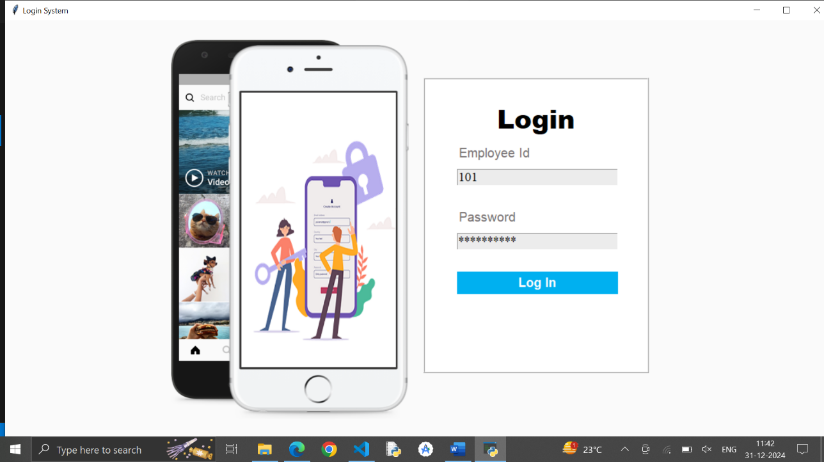
Description: This page display login form for employee. Employee can login with employee id and password.

Code:
from tkinter import *
from PIL import ImageTk
from tkinter import messagebox
import mysql.connector
import os
class Login_System:
def __init__(self,root):
self.root=root
self.root.title("Login System")
self.root.geometry("1350x700+0+0")
self.root.config(bg="#fafafa")

self.phone_image=ImageTk.PhotoImage(file="phone.png")
self.lbl_Phone_image=Label(self.root,image=self.phone_image,bd=0).place(x=200,y=10)

self.employee_id=StringVar()
self.password=StringVar()

login_frame=Frame(self.root,bd=2,relief=RIDGE,bg="white")
login_frame.place(x=650,y=90,width=350,height=460)

title=Label(login_frame,text="Login", font=("Arial Black",30,"bold"),bg="white").place(x=0,y=30,relwidth=1)

lbl_user=Label(login_frame,text="Employee Id",font=("Andalus",15),bg="white",fg="#767171").place(x=50,y=100)
txt_employee_id=Entry(login_frame,textvariable=self.employee_id,font=('times new roman',15),bg="#ececec").place(x=50,y=140,width=250)

lbl_pass=Label(login_frame,text="Password",font=("Andalus",15),bg="white",fg="#767171").place(x=50,y=200)
txt_pass=Entry(login_frame,textvariable=self.password,show="*",font=('times new roman',15),bg="#ececec").place(x=50,y=240,width=250)

btn_login=Button(login_frame,text="Log In",command=self.login,font=("Arial Rounded MT Bold",15,"bold"),bg="#00b0f0",fg="white",activebackground="#00b0f0",activeforeground="white",bd=0,cursor="hand2").place(x=50,y=300,width=250,height=35)

"""hr=Label(login_frame,bg="lightgray").place(x=50,y=370,width=250,height=2)
or_=Label(login_frame,text="OR",bg="white",fg="lightgray",font=("times new roman",15,"bold")).place(x=160,y=355)"""

#btn_forget=Button(login_frame,text="Forget Password?",command=self.forget_window,font=("times new roman",13),bg="white",fg="#00759e",activebackground="white",activeforeground="#00759e",bd=0,cursor="hand2").place(x=110,y=390)

self.im1=ImageTk.PhotoImage(file="im1.png")
self.im2=ImageTk.PhotoImage(file="im2.png")
self.im3=ImageTk.PhotoImage(file="im3.png")

self.lbl_change_image=Label(self.root,bg="gray")
self.lbl_change_image.place(x=367,y=113,width=240,height=428)

self.animate()

def animate(self):
self.im=self.im1
self.im1=self.im2
self.im2=self.im3
self.im3=self.im
self.lbl_change_image.config(image=self.im)
self.lbl_change_image.after(1500,self.animate)

root=Tk()
obj=Login_System(root)
root.mainloop()

Employee Dashboard

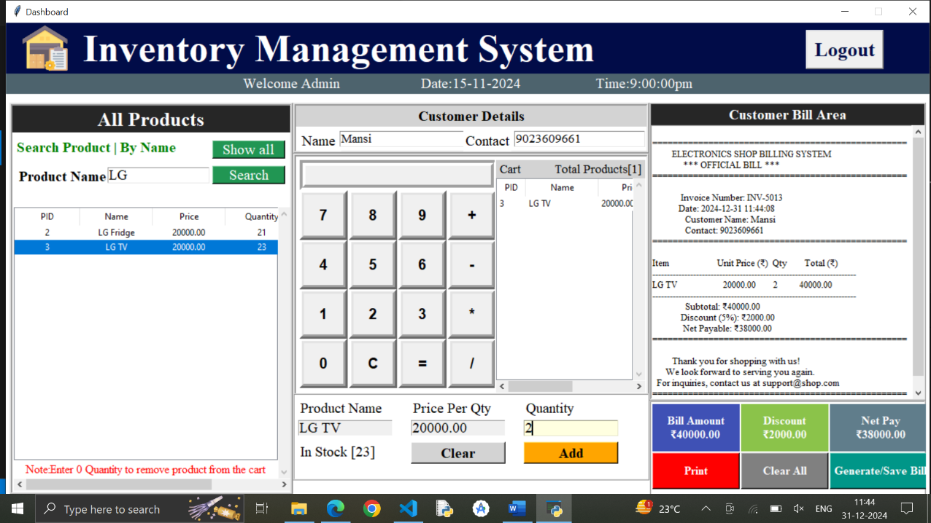
Description: In this page, Employee can generate bill according to customer’s choice

Code:
import tkinter as tk
from tkinter import *
from PIL import ImageTk
from tkinter import ttk
from tkinter import messagebox
from tkcalendar import DateEntry
import mysql.connector
from datetime import date
import datetime
from datetime import datetime
import os
from tkinter import filedialog

import os
#GUI Part
# Create a Tkinter window
window = Tk()
window.title("Dashboard")
window.geometry("1270x668+0+0")
window.resizable(0, 0)
window.config(bg='white')
def redirect_to_login():
window.destroy() # Close the current window
os.system('python logine.py')
# Load background image
bg_image = PhotoImage(file='inventory.png')

# Title label with image and text
titleLabel = Label(window, image=bg_image, compound=LEFT,text="Inventory Management System",
font=("times new roman", 40, "bold"), bg="#010c48", fg="white",anchor="w",padx=20)
titleLabel.place(x=0, y=0,relwidth=1)
cart_list=[]

logoutButton = Button(window, text="Logout", font=('times new roman', 20, 'bold'), fg='#010c48', command=redirect_to_login,cursor="hand2")
logoutButton.place(x=1100, y=10)

subtitleLabel=Label(window,text="Welcome Admin\t\t Date:15-11-2024\t\t Time:9:00:00pm",font=('times new roman',15),bg='#4d636d',fg='white')
subtitleLabel.place(x=0,y=70,relwidth=1)

varsearch=StringVar()
product_frame=Frame(window,bd=4,relief=RIDGE,bg="white")
product_frame.place(x=5,y=110,width=390,height=540)
pTitle=Label(product_frame,text="All Products",font=('times new roman',20,'bold'),bg="#262626",fg="white").pack(side=TOP,fill=X)

product_frame2=Frame(product_frame,relief=RIDGE,bg="white")
product_frame2.place(x=1,y=38,width=380,height=90)

lblsearch=Label(product_frame2,text="Search Product | By Name ",font=('times new roman',15,'bold'),bg="white",fg="green").place(x=2,y=5)

lblname=Label(product_frame2,text="Product Name ",font=('times new roman',15,'bold'),bg="white").place(x=5,y=45)
txtsearch=Entry(product_frame2,textvariable=varsearch,font=('times new roman',15),bg="white").place(x=130,y=47,width=140,height=22)
# ... other code

# Create the button
btnsearch = Button(product_frame2, text="Search", font=('times new roman', 15), bg="#219653", fg="white", cursor="hand2")

# Place the button
btnsearch.place(x=274, y=45, width=100, height=25)

# Configure the command (this is the crucial change)
btnsearch.config(command=lambda:search_products)

# ... rest of your code
# ... other code

# Create the button
btnshowall = Button(product_frame2, text="Show all", font=('times new roman', 15), bg="#219653", fg="white", cursor="hand2")

# Place the button
btnshowall.place(x=274, y=10, width=100, height=25)

# **Directly assign function**
btnshowall.config(command=lambda: show_all_products())
# ... rest of your code
product_frame3=Frame(product_frame,relief=RIDGE)
product_frame3.place(x=2,y=140,width=380,height=390)

scrolly=Scrollbar(product_frame3,orient=VERTICAL)
scrollx=Scrollbar(product_frame3,orient=HORIZONTAL)

product_table=ttk.Treeview(product_frame3,columns=("pid","name","price","qty","status"),yscrollcommand=scrolly.set,xscrollcommand=scrollx.set)
scrollx.pack(side=BOTTOM,fill=X)
scrolly.pack(side=RIGHT,fill=Y)
scrollx.config(command=product_table.xview)
scrolly.config(command=product_table.yview)
def get_data(ev):
selected_row = product_table.focus()
if selected_row: # Check if a row is actually selected
content = product_table.item(selected_row)
row = content['values']
var_pid.set(row[0])
var_pname.set(row[1])
var_price.set(row[2])
# Check if quantity information exists (at least 4 elements)
if len(row) >= 4:
lbl_inStock.config(text=f"In Stock [{row[3]}]")
else:
lbl_inStock.config(text="In Stock [Data Missing]") # Handle missing data
else:
# Handle the case where no row is selected
var_pid.set("")
var_pname.set("")
var_price.set("")
lbl_inStock.config(text="In Stock [-]") # Clear display or show default message

product_table.heading("pid",text="PID")
product_table.heading("name",text="Name")
product_table.heading("price",text="Price")
product_table.heading("qty",text="Quantity")
product_table.heading("status",text="Status")
product_table["show"]="headings"
product_table.column("pid",anchor=tk.CENTER,width=90)
product_table.column("name",anchor=tk.CENTER,width=100)
product_table.column("price",anchor=tk.CENTER,width=100)
product_table.column("qty",anchor=tk.CENTER,width=100)
product_table.column("status",anchor=tk.CENTER,width=100)
product_table.pack(fill=BOTH,expand=1)
product_table.bind("<ButtonRelease-1>", get_data)

lbl_note=Label(product_frame3,text="Note:Enter 0 Quantity to remove product from the cart",font=('times new roman',12),bg="white",fg="red").pack(side=BOTTOM,fill=X)

customer_frame=Frame(window,bd=4,relief=RIDGE,bg="white")
customer_frame.place(x=395,y=110,width=490,height=70)

pTitle=Label(customer_frame,text="Customer Details",font=('times new roman',15,'bold'),bg="lightgray").pack(side=TOP,fill=X)

var_cname=StringVar()
var_contact=StringVar()
lblname=Label(customer_frame,text="Name ",font=('times new roman',15),bg="white").place(x=5,y=35)
txtsearch=Entry(customer_frame,textvariable=var_cname,font=('times new roman',13),bg="white").place(x=60,y=35,width=180,height=22)

lblcontact=Label(customer_frame,text="Contact",font=('times new roman',15),bg="white").place(x=230,y=35)
txtcontact=Entry(customer_frame,textvariable=var_contact,font=('times new roman',13),bg="white").place(x=300,y=35,width=180,height=22)

cal_cart_Frame=Frame(window,bd=4,relief=RIDGE,bg="white")
cal_cart_Frame.place(x=395,y=180,width=490,height=340)

var_cal_input=StringVar()
cal_Frame=Frame(cal_cart_Frame,relief=RIDGE,bg="white")
cal_Frame.place(x=5,y=5,width=268,height=320)

txt_cal_input=Entry(cal_Frame,textvariable=var_cal_input,font=('arial',15,'bold'),width=23,bd=8,relief=GROOVE,state='readonly',justify=RIGHT)
txt_cal_input.grid(row=0,columnspan=4)

btn_7=Button(cal_Frame,text='7',font=('arial',15,'bold'),command=lambda:get_input(7),bd=6,width=4,height=1,pady=10,cursor="hand2").grid(row=1,column=0)
btn_8=Button(cal_Frame,text='8',font=('arial',15,'bold'),command=lambda:get_input(8),bd=6,width=4,height=1,pady=10,cursor="hand2").grid(row=1,column=1)
btn_9=Button(cal_Frame,text='9',font=('arial',15,'bold'),command=lambda:get_input(9),bd=6,width=4,height=1,pady=10,cursor="hand2").grid(row=1,column=2)
btn_sum=Button(cal_Frame,text='+',font=('arial',15,'bold'),command=lambda:get_input('+'),bd=6,width=4,height=1,pady=10,cursor="hand2").grid(row=1,column=3)

btn_4=Button(cal_Frame,text='4',font=('arial',15,'bold'),command=lambda:get_input(4),bd=6,width=4,height=1,pady=10,cursor="hand2").grid(row=2,column=0)
btn_5=Button(cal_Frame,text='5',font=('arial',15,'bold'),command=lambda:get_input(5),bd=6,width=4,height=1,pady=10,cursor="hand2").grid(row=2,column=1)
btn_6=Button(cal_Frame,text='6',font=('arial',15,'bold'),command=lambda:get_input(6),bd=6,width=4,height=1,pady=10,cursor="hand2").grid(row=2,column=2)
btn_sub=Button(cal_Frame,text='-',font=('arial',15,'bold'),command=lambda:get_input('-'),bd=6,width=4,height=1,pady=10,cursor="hand2").grid(row=2,column=3)

btn_1=Button(cal_Frame,text='1',font=('arial',15,'bold'),command=lambda:get_input(1),bd=6,width=4,height=1,pady=10,cursor="hand2").grid(row=3,column=0)
btn_2=Button(cal_Frame,text='2',font=('arial',15,'bold'),command=lambda:get_input(2),bd=6,width=4,height=1,pady=10,cursor="hand2").grid(row=3,column=1)
btn_3=Button(cal_Frame,text='3',font=('arial',15,'bold'),command=lambda:get_input(3),bd=6,width=4,height=1,pady=10,cursor="hand2").grid(row=3,column=2)
btn_mul=Button(cal_Frame,text='*',font=('arial',15,'bold'),command=lambda:get_input('*'),bd=6,width=4,height=1,pady=10,cursor="hand2").grid(row=3,column=3)

btn_0=Button(cal_Frame,text='0',font=('arial',15,'bold'),command=lambda:get_input(0),bd=6,width=4,height=1,pady=10,cursor="hand2").grid(row=4,column=0)
btn_c=Button(cal_Frame,text='C',font=('arial',15,'bold'),command=lambda:clear_cal(),bd=6,width=4,height=1,pady=10,cursor="hand2").grid(row=4,column=1)
btn_eq=Button(cal_Frame,text='=',font=('arial',15,'bold'),command=lambda:perform_cal(),bd=6,width=4,height=1,pady=10,cursor="hand2").grid(row=4,column=2)
btn_div=Button(cal_Frame,text='/',font=('arial',15,'bold'),command=lambda:get_input('/'),bd=6,width=4,height=1,pady=10,cursor="hand2").grid(row=4,column=3)

cart_frame=Frame(cal_cart_Frame,relief=RIDGE,bd=0)
cart_frame.place(x=275,y=5,width=205,height=320)
cartTitle = Label(cart_frame, text="Cart \t Total Products[0]", font=('times new roman', 13), bg="lightgray")
cartTitle.pack(side=TOP, fill=X)

scrolly=Scrollbar(cart_frame,orient=VERTICAL)
scrollx=Scrollbar(cart_frame,orient=HORIZONTAL)

cart_table=ttk.Treeview(cart_frame,columns=("pid","name","price","qty","status"),yscrollcommand=scrolly.set,xscrollcommand=scrollx.set)
scrollx.pack(side=BOTTOM,fill=X)
scrolly.pack(side=RIGHT,fill=Y)
scrollx.config(command=cart_table.xview)
scrolly.config(command=cart_table.yview)

cart_table.heading("pid",text="PID")
cart_table.heading("name",text="Name")
cart_table.heading("price",text="Price")
cart_table.heading("qty",text="Quantity")
cart_table.heading("status",text="Status")
cart_table["show"]="headings"
cart_table.column("pid",width=40)
cart_table.column("name",width=100)
cart_table.column("price",width=90)
cart_table.column("qty",width=40)
cart_table.column("status",width=90)
cart_table.pack(fill=BOTH,expand=1)

var_pid=StringVar()
var_pname=StringVar()
var_price=StringVar()
var_qty=StringVar()
var_stock=StringVar()

Add_CartWidgetsFrame=Frame(window,bd=2,relief=RIDGE,bg="white")
Add_CartWidgetsFrame.place(x=395,y=510,width=490,height=120)

lbl_p_name=Label(Add_CartWidgetsFrame,text="Product Name",font=("times new roman",15),bg="white").place(x=5,y=5)
txt_p_name=Entry(Add_CartWidgetsFrame,textvariable=var_pname,font=("times new roman",15),bg="lightyellow",state='readonly').place(x=5,y=35,width=130,height=22)

lbl_p_price=Label(Add_CartWidgetsFrame,text="Price Per Qty",font=("times new roman",15),bg="white").place(x=160,y=5)
txt_p_price=Entry(Add_CartWidgetsFrame,textvariable=var_price,font=("times new roman",15),bg="lightyellow",state='readonly').place(x=160,y=35,width=130,height=22)

lbl_p_qty=Label(Add_CartWidgetsFrame,text="Quantity",font=("times new roman",15),bg="white").place(x=315,y=5)
txt_p_qty=Entry(Add_CartWidgetsFrame,textvariable=var_qty,font=("times new roman",15),bg="lightyellow").place(x=315,y=35,width=130,height=22)

lbl_inStock = Label(Add_CartWidgetsFrame, text="In Stock [9999]", font=("times new roman", 15), bg="white")
lbl_inStock.place(x=5, y=65)
btn_clear_cart=Button(Add_CartWidgetsFrame,text="Clear",font=("times new roman",15,"bold"),bg="lightgray",cursor="hand2", command=lambda: clear_cart_widgets()).place(x=160,y=65,width=130,height=30)
btn_add_cart = Button(Add_CartWidgetsFrame,
text="Add",
command=lambda: add_update_cart(),
font=("times new roman", 15, "bold"),
bg="orange",
cursor="hand2")
btn_add_cart.place(x=315, y=65, width=130, height=30)
billFrame=Frame(window,bd=2,relief=RIDGE,bg='white')
billFrame.place(x=885,y=110,width=380,height=410)

BTitle=Label(billFrame,text="Customer Bill Area",font=('times new roman',15,'bold'),bg="#262626",fg="white").pack(side=TOP,fill=X)
scrolly=Scrollbar(billFrame,orient=VERTICAL)
scrolly.pack(side=RIGHT,fill=Y)
txt_bill_area=Text(billFrame,yscrollcommand=scrolly.set,font=('times new roman',10))
txt_bill_area.pack(fill=BOTH,expand=1)
scrolly.config(command=txt_bill_area)

billMenuFrame=Frame(window,bd=2,relief=RIDGE,bg='white')
billMenuFrame.place(x=885,y=520,width=380,height=140)

lbl_amnt=Label(billMenuFrame,text='Bill Amount\n[0]',font=('times new roman',12,'bold'),bg="#3f51b5",fg="white")
lbl_amnt.place(x=2,y=3,width=120,height=65)

lbl_discount=Label(billMenuFrame,text='Discount\n[5%]',font=('times new roman',12,'bold'),bg="#8bc34a",fg="white")
lbl_discount.place(x=124,y=3,width=120,height=65)

lbl_net_pay=Label(billMenuFrame,text='Net Pay\n[0]',font=('times new roman',12,'bold'),bg="#607d8b",fg="white")
lbl_net_pay.place(x=246,y=3,width=140,height=65)

btn_print=Button(billMenuFrame,text='Print',cursor='hand2',font=('times new roman',12,'bold'),bg="red",fg="white")
btn_print.place(x=2,y=70,width=120,height=50)

btn_clear_all=Button(billMenuFrame,text='Clear All',cursor='hand2',font=('times new roman',12,'bold'),bg="gray",fg="white",command=lambda:clear_allb)
btn_clear_all.place(x=124,y=70,width=120,height=50)

btn_generate = Button(billMenuFrame,
text='Generate/Save Bill',
cursor='hand2',
font=('times new roman', 12, 'bold'),
bg="#009688",
fg="white",
command=lambda:generate_bill) # Assign the function here
btn_generate.place(x=246, y=70, width=140, height=50)

def get_input(num):
xnum=var_cal_input.get()+str(num)
var_cal_input.set(xnum)
def clear_cal():
var_cal_input.set('')

def perform_cal():
result=var_cal_input.get()
var_cal_input.set(eval(result))

def generate_bill():
"""Generates a professionally formatted, center-aligned bill, decreases product quantities,
stores it in the database, and saves it as a .txt file."""
from datetime import datetime
import mysql.connector
from tkinter import messagebox
import tkinter as tk
import random
import os

try:
# Database connection
db = mysql.connector.connect(
host="localhost",
user="root",
password="",
database="inventory_system"
)
cursor = db.cursor()

# Current date and time
current_date = datetime.now().strftime('%Y-%m-%d %H:%M:%S')

# Generate a random invoice number
invoice_number = f"INV-{random.randint(1000, 9999)}"

# Retrieve customer details
customer_name = var_cname.get().strip()
customer_contact = var_contact.get().strip()

# Validate customer name and contact
if not customer_name:
messagebox.showerror("Error", "Customer name is required", parent=window)
return
if not customer_contact:
messagebox.showerror("Error", "Contact number is required", parent=window)
return
if not customer_contact.isdigit() or len(customer_contact) != 10:
messagebox.showerror("Error", "Enter a valid 10-digit contact number", parent=window)
return

# Check if cart is empty
cart_items = cart_table.get_children()
if not cart_items:
messagebox.showerror("Error", "Cart is empty! Please add items before generating a bill.", parent=window)
return

# Calculate total amount and prepare item data
total_amount = 0.0
item_data = []
for item in cart_items:
item_values = cart_table.item(item)['values']
item_id = item_values[0] # Assuming the first value is the product ID
item_name = item_values[1]
item_price = float(item_values[2])
item_qty = int(item_values[3])
item_total = item_price * item_qty
total_amount += item_total
item_data.append((item_id, item_name, item_price, item_qty, item_total))

# Apply discount
discount_rate = 0.05 # 5% discount
discount_amount = total_amount * discount_rate
net_payable = total_amount - discount_amount

# Insert bill data into the `bills` table
cursor.execute(
"INSERT INTO bills (invoice_number, customer_name, customer_contact, bill_date, subtotal, discount_amount, net_payable) "
"VALUES (%s, %s, %s, %s, %s, %s, %s)",
(invoice_number, customer_name, customer_contact, current_date, total_amount, discount_amount, net_payable)
)
bill_id = cursor.lastrowid

# Insert items into the `bill_items` table and update product quantities
for item in item_data:
product_id = item[0]
item_name = item[1]
item_price = item[2]
item_qty = item[3]
item_total = item[4]

# Insert into `bill_items`
cursor.execute(
"INSERT INTO bill_items (bill_id, item_name, item_price, item_qty, item_total) VALUES (%s, %s, %s, %s, %s)",
(bill_id, item_name, item_price, item_qty, item_total)
)

# Update product quantity
cursor.execute(
"UPDATE product_data SET quantity = quantity - %s WHERE id = %s AND quantity >= %s",
(item_qty, product_id, item_qty)
)
if cursor.rowcount == 0:
db.rollback()
messagebox.showerror("Error", f"Insufficient stock for product ID: {product_id}", parent=window)
return

db.commit()

# Generate the bill text
bill_width = 50
center = lambda text: text.center(bill_width)

bill_text = "\n"
bill_text += "=" * bill_width + "\n"
bill_text += center("ELECTRONICS SHOP BILLING SYSTEM") + "\n"
bill_text += center("*** OFFICIAL BILL ***") + "\n"
bill_text += "=" * bill_width + "\n\n"
bill_text += f"{center(f'Invoice Number: {invoice_number}')} \n"
bill_text += f"{center(f'Date: {current_date}')} \n"
bill_text += f"{center(f'Customer Name: {customer_name}')} \n"
bill_text += f"{center(f'Contact: {customer_contact}')} \n"
bill_text += "=" * bill_width + "\n\n"

# Table header
bill_text += center("{:<25} {:<15} {:<10} {:<15}".format("Item", "Unit Price (₹)", "Qty", "Total (₹)")) + "\n"
bill_text += center("-" * 70) + "\n"

# Table content
for item in item_data:
item_line = "{:<25} {:<15.2f} {:<10} {:<15.2f}".format(item[1][:25], item[2], item[3], item[4])
bill_text += center(item_line) + "\n"

bill_text += center("-" * 70) + "\n"

# Summary
bill_text += f"{center(f'Subtotal: ₹{total_amount:.2f}')} \n"
bill_text += f"{center(f'Discount (5%): ₹{discount_amount:.2f}')} \n"
bill_text += f"{center(f'Net Payable: ₹{net_payable:.2f}')} \n"
bill_text += "=" * bill_width + "\n\n"

# Footer
bill_text += center("Thank you for shopping with us!") + "\n"
bill_text += center("We look forward to serving you again.") + "\n"
bill_text += center("For inquiries, contact us at support@shop.com") + "\n"
bill_text += "=" * bill_width + "\n"

# Display the bill
txt_bill_area.delete("1.0", tk.END)
txt_bill_area.insert("1.0", bill_text)

# Save the bill as a .txt file
save_path = os.path.join(os.getcwd(), "bills") # Save in a "bills" directory
os.makedirs(save_path, exist_ok=True)
file_name = f"{invoice_number}.txt"
file_path = os.path.join(save_path, file_name)
with open(file_path, "w", encoding="utf-8") as file:
file.write(bill_text)

messagebox.showinfo("Saved", f"Bill saved successfully as {file_name}", parent=window)

# Update summary labels
lbl_amnt.config(text=f"Bill Amount\n₹{total_amount:.2f}")
lbl_discount.config(text=f"Discount\n₹{discount_amount:.2f}")
lbl_net_pay.config(text=f"Net Pay\n₹{net_payable:.2f}")

except mysql.connector.Error as db_error:
messagebox.showerror("Database Error", f"Error interacting with the database: {str(db_error)}", parent=window)
except Exception as e:
messagebox.showerror("Error", f"An error occurred: {str(e)}", parent=window)
finally:
if 'db' in locals() and db.is_connected():
cursor.close()
db.close()

def clear_allb():
"""Clears all bill-related information."""

# Clear bill area text
txt_bill_area.delete("1.0", tk.END)

# Clear cart
for item in cart_table.get_children():
cart_table.delete(item)
cartTitle.config(text="Cart \t Total Products[0]")

# Clear customer details
var_cname.set("")
var_contact.set("")

# Clear bill amount labels
lbl_amnt.config(text='Bill Amount\n[0]')
lbl_discount.config(text='Discount\n[5%]')
lbl_net_pay.config(text='Net Pay\n[0]')

# Assuming btn_clear_all is defined earlier in your code:
btn_clear_all.config(command=clear_allb)
btnsearch.config(command=search_products)
btn_generate.config(command=generate_bill)
# Main event loop
show_all_products()
window.mainloop()

Budget and Financial Plan

Cost Estimation

Hardware Costs
Item | Quantity | Cost (INR) | Total Cost (INR)
Computer/Laptop (Development) | 1 | 45,000 | 45,000
Internet Connection | 1 | 1,000/month | 6,000 (for 6 months)
Printer (for billing, optional) | 1 | 8,000 | 8,000
Hardware Cost Total: ₹59,000
Software Costs
Software | Cost (INR)
Python (Open-source) | Free
MySQL (Community Edition) | Free
Tkinter (Built-in with Python) | Free
NetBeans IDE (optional) | Free
OS (Windows/Linux) | Already installed (assumed)
Software Cost Total: ₹0
3. Development Costs
Development Activity | Estimated Cost (INR)
System Design (ERD, GUI, etc.) | 10,000
Coding and Development | 25,000
Testing and Debugging | 8,000
Documentation Preparation | 5,000
Development Cost Total: ₹48,000
4. Maintenance Costs
Maintenance Activity | Estimated Cost (INR)
System Updates (Yearly) | 5,000
Bug Fixes and Enhancements | 3,000
Annual Maintenance Cost: ₹8,000

Financial Planning

1. Budget Breakdown
Category | Estimated Cost (INR)
Hardware (PC, printer, etc.) | ₹50,000
Development Cost | ₹40,000
Maintenance (First Year) | ₹10,000
Total Budget: ₹1,00,000
2. Funding Options
- Self-Funding: Use savings or business profits.
- Bank Loan: Apply for a small business or IT-specific loan.
- Government Schemes: Check for grants supporting digital transformation.
3. Estimated Benefits
- Time Savings: Faster billing and inventory management.
- Cost Savings: Reduce errors and manual work, saving ₹5,000/month.
- Revenue Growth: Better customer service may increase sales by ₹10,000/month.
Total Monthly Benefit: ₹15,000
Annual Benefit: ₹15,000 × 12 = ₹1,80,000

Future Enhancement

- Integration with Barcode Scanning
  - Feature: Add barcode scanner support for products to speed up billing and inventory updates.
  - Benefit: Reduces manual errors and improves efficiency in product management.
- Online Ordering System
  - Feature: Allow customers to browse inventory and place orders online.
  - Benefit: Expands your business reach and increases sales.
- Advanced Sales Reporting
  - Feature: Add features like monthly/quarterly sales trends, low-stock alerts, and profit analysis.
  - Benefit: Helps owners make informed decisions and optimize inventory management.
- Mobile App Integration
  - Feature: Develop a mobile app for owners and employees to manage the system remotely.
  - Benefit: Enables real-time inventory and sales tracking on the go.
- Customer Management System
  - Feature: Store customer information and purchase history.
  - Benefit: Helps with loyalty programs, personalized offers, and improved customer service.
- Multi-Store Management
  - Feature: Expand the system to handle multiple store locations.
  - Benefit: Centralized management of inventory and sales across all branches.
- AI-Based Demand Prediction
  - Feature: Use AI algorithms to predict demand for products based on past sales data.
  - Benefit: Optimizes inventory stocking and reduces wastage.
- Integration with Payment Gateways
  - Feature: Support multiple payment modes like UPI, credit/debit cards, and wallets.
  - Benefit: Provides seamless payment options for customers and better billing experience.
- Employee Performance Analytics
  - Feature: Track employee performance based on sales, attendance, and productivity.
  - Benefit: Enhances workforce management and rewards top performers.
- Cloud-Based Data Storage
  - Feature: Store data on the cloud instead of local servers.
  - Benefit: Ensures data security, scalability, and easy remote access.

Conclusion

The "Electronics Shop Inventory Management System" is a comprehensive solution tailored to streamline the operational needs of an electronics shop. By incorporating features such as employee management, supplier management, category and product management, billing, and sales reporting, the system enhances efficiency, reduces manual workload, and minimizes errors.
With its user-friendly interface and robust functionality, the system not only simplifies inventory management but also contributes to improved decision-making through detailed sales analysis. Designed with Python Tkinter and MySQL, it ensures reliability, scalability, and easy maintenance.
This system empowers shop owners and employees to focus on customer satisfaction and business growth. With future enhancements, such as online ordering, mobile app integration, and AI-based demand prediction, the system has the potential to evolve into a cutting-edge tool that meets the ever-changing demands of the retail industry.
Overall, the project delivers significant value by increasing operational efficiency, optimizing resource utilization, and driving profitability.

References

- Python Documentation
  - URL: https://docs.python.org/3/
  - Description: Official documentation for Python programming, used for implementing the backend logic of the system.
- Tkinter Documentation
  - URL: https://docs.python.org/3/library/tkinter.html
  - Description: Reference for designing the graphical user interface (GUI) of the system.
- MySQL Documentation
  - URL: https://dev.mysql.com/doc/
  - Description: Official documentation for MySQL, used for database design and management.
- Stack Overflow
  - URL: https://stackoverflow.com/
  - Description: Community-driven platform for resolving technical challenges during development.
- W3Schools
  - URL: https://www.w3schools.com/
  - Description: Resource for learning SQL queries, Python basics, and other web technologies.
- GeeksforGeeks
  - URL: https://www.geeksforgeeks.org/
  - Description: Educational platform used for understanding programming concepts and database operations.
- Real Python
  - URL: https://realpython.com/
  - Description: Comprehensive tutorials on Python programming, used for understanding Python best practices.
- TutorialsPoint
  - URL: https://www.tutorialspoint.com/
  - Description: Platform offering beginner-to-advanced tutorials on Python, Tkinter, and MySQL.

